Diffraction : Taking Light Apart

This suite of activities provides an opportunity for hands-on understanding of the phenomenon of diffraction of light. Astronomers use diffraction of light to disperse (or spread out) colors of light from astronomical light sources into a spectrum. The spectrum is then used to measure the physical characteristics of that source.

Science Standards
TEKS IPC:

Science concepts. The student knows the effects of waves on everyday life. The student is expected to:
(A) demonstrate wave types and their characteristics through a variety of activities such as modeling with ropes and coils, activating tuning forks, and interpreting data on seismic waves;
(B) demonstrate wave interactions including interference, polarization, reflection, refraction, and resonance within various materials;
(C) identify uses of electromagnetic waves in various technological applications such as fiber optics, optical scanners, and microwaves

TEKS Physics:

(8) Science concepts. The student knows the characteristics and behavior of waves. The student is expected to:
(A) examine and describe a variety of waves propagated in various types of media and describe wave characteristics such as velocity, frequency, amplitude, and behaviors such as reflection, refraction, and interference;
(B) identify the characteristics and behaviors of sound and electromagnetic waves; and
(C) interpret the role of wave characteristics and behaviors found in medicinal and industrial applications.

Materials Required

• Diffraction Materials Card (at least one per team).
Note that the card is incorrectly labeled – the last "hole" is 5000/cm
available from several sources – see http://www.envisionlabs.com/optics.html
• Centimeter ruler and tape measure or meter stick (one each per team)
• Laser pointer (one per team)
• CD disk - without a label on it (one per team)
• Incandescent light source
– ideally a naked bulb >60W, with no shield around it, and unfrosted
• prism (for comparison) optional
* optional: applets such as at http://phet.colorado.edu/web-pages/index.html

A. Engagement

Let’s stop to consider diffraction. It’s part of everyday life, in which waves of energy don’t seem to move in straight lines.

1. Pick up a CD disk and look at the reflection of a light in it. In what way does it act like a mirror? In what way does it not act like a mirror? We’ll look more carefully at CDs later.

The reflection of the light seems like a mirror, but there are colors that seem to be coming from the light that are reflecting off the CD at odd angles.

2. A jetty sticks out into the ocean. (Show transparency of jetty and the ocean waves before hitting the jetty.) Does it block ocean waves entirely? Does it make a sharp wave-shadow? Can waves get around the jetty? Make a sketch of how the waves behave when they hit an edge.

Students should understand that waves hitting a blockage do not cast a sharp shadow. They may come up with drawings that look like this. The point is that the energy in the waves doesn’t have to move in a straightline.
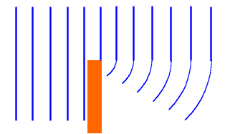

You may wish to have them compare their result to an applet such as
http://www.ngsir.netfirms.com/englishhtm/Diffraction3.htm

3. Your friend is on the other side of a wall. She calls to you. You can’t see her, but you can hear her. Knowing that sound is just waves traveling through air, and in view of the behavior of water waves around a jetty (see above), discuss why it is you can hear her.
Hey dude. You there?

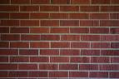

Students should appreciate that, in this case, sound didn’t travel in a straight line. The sound must have been bent, like the water waves around a jetty. Now, they might also wonder if there was something else that the sound could have bounced off of.

OK, there’s something a little strange going on, and we call it “diffraction”. We’re going to talk about diffraction as applied to light.

B. Diffraction and Refraction

We can disperse light into a spectrum using materials that bend different colors of light differently when the light travels through them (e.g. prisms, using the phenomenon of refraction), or materials that bend different colors of light differently because of a grid pattern on them (e.g. diffraction gratings – using the phenomenon of diffraction). Astronomers like to use the latter, rather than the former, because faint starlight doesn’t have to pass through thick pieces of material.
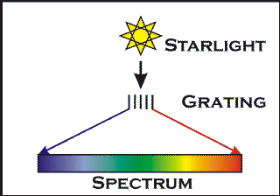

The student sheets at this point introduce an optional activity with a prism.

C. Some Background on Light as Waves

We can understand diffraction if we think about light as having wave-like properties. We can think about light in this way by thinking about familiar waves, like waves in water.

1. When waves from two sources cross, as in the picture above, they either reinforce each other (constructive interference) or cancel each other (destructive interference).

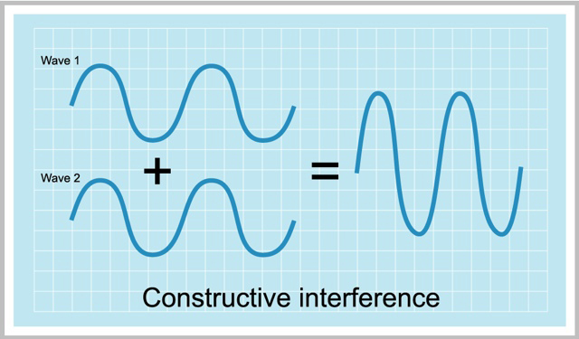
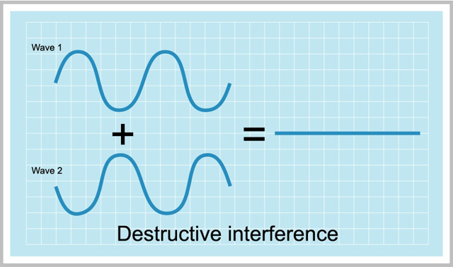

For light waves, there is no “higher” or “lower”, like there is for waves in water. Rather, the wave is the direction of the electric field, and when an “up” pointing part of a wave hits a “down” pointing part of another wave, they cancel. For the purposes of this activity, we’re going to think about light as traveling in plane waves. That is, although light from a source, whether it be a star or a lamp, radiates outward in spherical waves, when you get far enough away, each peak and dip in the wave can be thought of as being in a plane, and we’ll indicate that wave by parallel lines.

Consider carefully the figure above. Light from a distant source comes in from the left, and while the waves are really big circles on the paper, we can think of them as parallel plane waves. These plane waves hit a sheet of black paper in the middle. At this sheet, the sheet is uniformly lit up by the plane wave. This sheet has two holes in it for the light to go through. As the light goes through each, it expands in a circular wave. If we put a screen at far right to project it on, we see a row of bright spots where a peak from the wave from one hole overlaps the peak from the wave of the other hole. That’s amazing! With two holes, we convert uniform illumination, to a row of bright spots! We call this row of bright spots the “diffraction pattern” from the two holes.

At this point, you may wish to show an applet such as
http://id.mind.net/~zona/mstm/physics/waves/interference/waveInterference3/WaveInterference3.html

Remarkable, that these spots seem to mean that the light isn’t moving in a straight line!
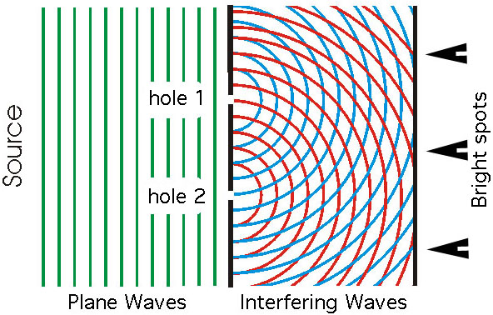

2. You may wish to show another applet now for the students to compare to their sketches, such as
http://www.ngsir.netfirms.com/englishhtm/Diffraction.htm

3. An applet for two openings is at
http://perg.phys.ksu.edu/vqmorig/programs/java/makewave/olddouble/Slit.html

D. Diffraction Materials Card

Each team has been given a “Diffraction Materials Card”, which is a set of materials in five portholes that has lots of holes or slots in a regular pattern. Four of the five materials are fine wire screen (so the holes go in two directions, left/right and up/down). You can see through each porthole, some better than others!


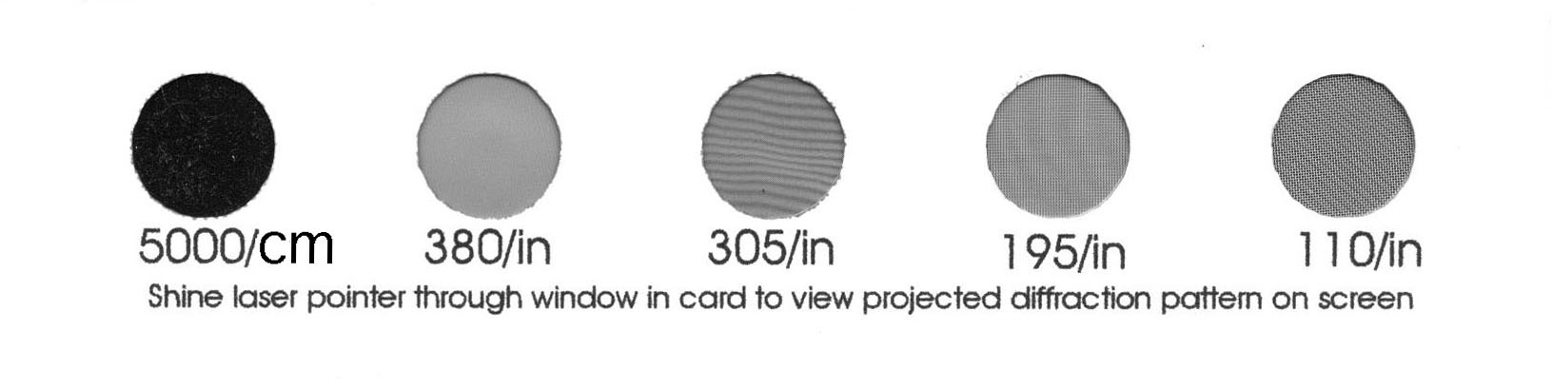

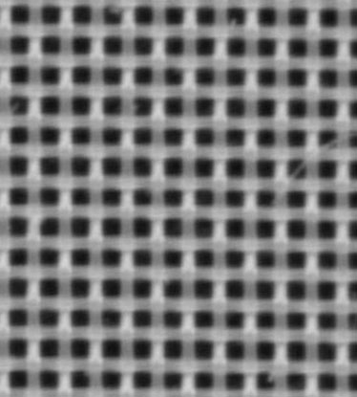
The four portholes at right have fine wire screen in them. If you looked at them under a microscope (see below), it would look like the picture at right.

The porthole at left is a special acetate film that has on it a very fine set of parallel ripples embossed on one side. These make the equivalent of one-dimensional holes, or slots. (Astronomers would call them “slits”.) Sorry, you can’t see the slots in this acetate!

Now, the spacing of the holes (in the wire screen) and the slits (in the acetate) is indicated under each one. The porthole at the far left has the coarsest spacing, and the one at the far right has the finest spacing.

E. Seeing Diffraction

1. Now look through the portholes at the incandescent bulb. Do this with the lamp on the other side of the room, so it appears very small from where you sit. Wow! Spots all over the place! Make a quick sketch of what you see through each one.

110/in 195/in 305/in

380/in 5000/cm

You may notice that each spot is stretched out a bit into a rainbow away from the light. For the 5000/cm porthole, each “spot” is a big long rainbow. Because that material is designed with slots in one dimension instead of holes in two dimensions, the diffraction only goes in one direction. You may also notice that the separation of the spots through each porthole depends on the mesh size.

2. Qualitatively, how does the spot separation depend on mesh size?

Students should understand that the row of spots is more spread out for the finer mesh. Students should be challenged to understand why the spots rotate around as you rotate the mesh.

If the light were bright enough, and you moved your head out of the way, these spots would be projected on the wall behind you. (You’ll do that soon!)

F. Measuring the Mesh

1. The numbers on each porthole indicate how fine the mesh is. But don’t trust us! We want you to check these numbers (at least for the wire mesh). If you have your own microscope, you can use it, but we’re going to give you pictures of the portholes (see Appendix A), and let you work out the hole spacing for yourself. We will measure the hole spacing “d” in units of millimeters. Take out your ruler; start counting spots. Note that the size of each porthole is ½ inch. Don’t count all the way across (!), and don’t try to be precise. Just do a quantitative estimate.

Porthole measured spacing “d” (millimeters)

110/in porthole ____________

195/in porthole ____________

305/in porthole ____________

380/in porthole ____________

OK, now that you’ve done this, you can convert to holes per inch, and see if you got close to the right answer!

Students should be challenged to measure piecewise. That is, take the printed enlargement and count how many grid elements per centimeter. Then scale that to the size of the porthole. That is, they shouldn't be counting out 190 squares across the 380/in ½ inch porthole!

G. Getting the Wavelength of Light Using Diffraction

Knowing that the spots that we see through the portholes are caused by constructive interference, and knowing the size of the mesh that lets us see these spots, we can measure the length of the wave of visual light. Of course, waves that we’re familiar with (like ripples on water, or waves in a Slinky that one shakes) are pretty long. Are peaks in the waves of visible light that far apart?

1. We’re going to do this by measuring the angle between the spots. Let’s use the diagram below to understand what we’re doing. We have two holes, separated by a spacing “d”. A plane wave hits these holes and is diffracted to the right. In this picture, looking at the places where the waves from the holes overlap and interfere constructively, we can see five spots across the screen at right. The lines mark the path toward the n=2 spot, which is at an angle θ away from the central spot. In this picture, the rings show the peak of the waves, and the separation of the rings is the wavelength λ.
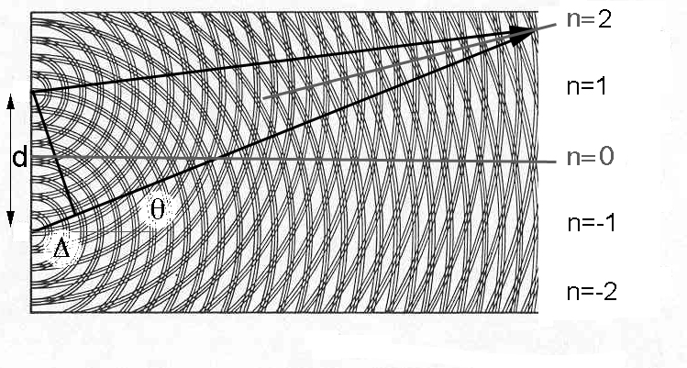

There is going to be a bright spot at the center (n=0, θ=0), because that is equidistant from both holes. But the only way one can have constructive interference is if Δ is a unit wavelength at each value of n. This is formalized in what we call the Grating Equation.

nλ = d sin θ = Δ

Students might use trigonometry to get comfortable with the above equation, and the triangle shown in the figure above and below. The beam (holes-to-spots) angle should be understood to be identical, by similarity, to the angle opposite Δ and adjacent to d. For those students who have not done trigonometry, just use the “small angle approximation” where
sin θ ∼ θ in radians ∼ y/L.

In general, specifically for the lines drawn about with n=2, θ is the angle from the center to the second spot. A simpler version is shown below.

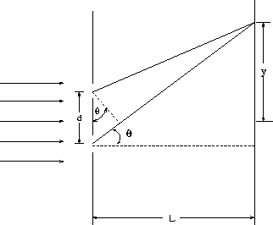

H. Measurement of Diffraction with the Eye

1. On a wall of the room, make marks (perhaps by taping up inch-wide strips of paper or tape that contrast well with the color of the wall) at ~10 cm intervals. Put the incandescent lamp near one end. So you end up with a wall that looks like this.



For a wall that is about eight meters away (L, above), you probably want about a dozen marks on the wall altogether.

Now hold one of the portholes over one eye and look at the lamp, perpendicular to the wall. Keep the other eye open and unblocked. You’ll see the array of spots (with one eye) superimposed on the marks on the wall (with the other eye).

VERY IMPORTANT! Students will find that the array of spots won’t be of equal brightness. Some will be very faint, and some will be very bright. Ignore that difference. But the spacing of the spots in each direction is a constant.

Why are they like that? Suffice it to say that if all the holes were very small, they would all appear about the same brightness. What you’re seeing is a superimposed interference pattern from the fact that the holes are finite sized.

See Annex Slides 1 & 2

2. Now walk toward and away from the wall until the spots line up with the marks on the wall. You will probably find that, unless the bulb is very small, you won’t even be able to distinguish the spots for the smaller mesh. They are much too close together. For the 5000/cm mesh size, the spot is such a stretched out rainbow that you’ll have to measure one particular color. Use yellow, which is more or less the middle of the whole rainbow.

Students may find that they can “move” the spots back and forth under the marks by crossing their eyes slightly. This takes a little practice. Another way of doing this is to have a team member be the measuring tool for y. That student would go out to distance L and hold his or her hands apart to gauge the spacing of the spots.

Use the tape measure or meter stick to get the distance to the wall (L) where the spots line up with the marks for each grid. Fill out the table with the “d” lengths you measured for the mesh, and your estimated errors for each measurement. Since you’re working with the ratio y/L, those units cancel when you measure both in cm. Your wavelength λ will be in millimeters, since that’s your unit for d.

Math note: θ = arctan (y/L,) or θ in radians ~ 10/L for small y/L if your lines are 10 cm apart. The small angle approximations is that θ in radians ~ tan θ ~ sin θ
Recall that since there are 2 π radians in a circle, divide the angle in degrees by 57.3 to get its value in radians. Students may wish to simply assume that for small angles
tan θ ~ sin θ and simply skip the step of calculating the actual angle.

πορτηολε δ Λ θ λ = δ σιν 
5000/cm  red light  yellow light  blue light | 0.0020 mm
380/in
305/in
195/in
110/in

For the mesh gratings, the spots are very close together, and the small y/L approximation applies. In fact, they probably won’t even be able to distinguish the spots for the coarsest mesh. But for the 5000/cm grating, they should use the trig function.

Astronomers use more convenient units than for the wavelength of visible light.
10000 Ångstroms = 0.001 mm
1000 nanometers = “
1 micron = “

• What did you find as a rough wavelength of yellow visible light?
In Ångstroms?
In nanometers?
In microns?

Students should find a wavelength of about 6000 Ångstroms (600 nanometers, 0.6 microns) for yellow light

• How many times “longer” is red light than blue light?

Students should find that red light (about 6000 Ångstroms) has a wavelength about 30% larger than for blue light (about 4500 Ångstroms)

• How does the wavelength of visible light compare to the “spacing” (d) of
the “diffraction gratings” in the Diffraction Card?

Students should understand that with a spot angle of about 30º, d~λ.

• How does the wavelength of light compare to other things?
- size of a carbon atom (~2 Ångstroms)
- size of a water molecule (~2 nanometers)
- thickness of a human hair (~50 microns)
- size of a paramecium (~200 microns)
- size of an E-Coli bacterium (~1 micron)
- wavelength of middle C in air (~130 cm)
- wavelength of a disturbance in water (~few meters)

I. Using Diffraction to Explore Compact Disks
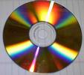
1. Let’s come back to CDs. Compact disks (CDs) store data on uniformly spaced concentric tracks. These tracks are embossed on the disks even when no data is put on the disks. It is easy to understand that these tracks diffract light by seeing the iridescence with which they reflect visible light. We can use our understanding of diffraction to measure the separation of these tracks.

Take a CD and, in the same way that you did for the Diffraction Card, look through it at the bright light. You should see a diffracted spectrum off on the side. (Depending on the thickness of the label-side dye, and embossed printing, the spot may be hard to see. Turn off the room lights to make it easier. Many bulk CD stacks come with a protective disk on top that is essentially a CD without the dye. This is the one that looks mostly clear. You might see if you have one of those that work.)

See Annex Slides 3 & 4

• Does the diffraction “spot” you see through the CD have an angle that is similar to that of any of the five “diffraction gratings” you experimented with above?

Yes. Students should see that the “spot” from the CD is at an angle (~20º) that is pretty similar to the spot from the 5000/cm sample (~15º)

• Can you estimate d for the CD? How far apart do you think the tracks are on a CD?

This would suggest that d for the CD is about 1.5 microns, a bit narrower than the 5000/cm sample.

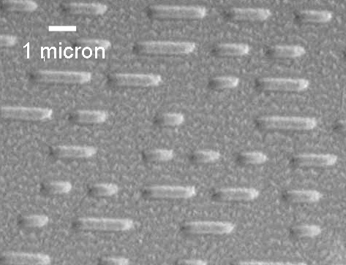

Compare your estimate for d with the electron microscope picture of a CD shown above, which shows the data bits represented as “pits” or segments on the groove tracks (which run roughly left to right).

Students should use the scale bar to see that the track separation is, indeed about 1.5 microns, or 0.0015 mm.

It is interesting to note that one can’t focus light onto a spot any smaller than its wavelength. The wavelength of the light can be considered to represent the “size” of the light particle, or photon. CDs are written with 650 nm (red) light beams. Is that consistent with the picture above?

Yes, the grooves in the picture (representing “bits” of data) are about 0.5 micron wide. That’s about 1/100 the width of a human hair!

• What are the physical limits for data storage on an optical disk? Calculate this using a 12 cm disk diameter, single side storage, and a writing beam that uses blue light.

Students should divide the area of the disk by the area of the smallest spot (0.65² square microns). They will get about 30x10⁹ that, in principle, is the number of “bits” of data one could fit on the disk. A byte is 8 bits, so this would suggest that one could fit about 4 gigabytes on the disk. In fact, a CD can hold only about 500 megabytes. The difference is clear by looking at the picture above. The bits are not packed very efficiently in a CD. See below.

J. Using a Laser to Explore Diffraction (optional)

LASER SAFETY – laser pointers are usually very low power devices (~1 mW), but the beam they produce is very concentrated. Even the low power ones can cause temporary visual problems. But modern laser technology allows brighter, more powerful (~5 mW) lasers in a small hand-held package, and these are being marketed. Such lasers can cause permanent damage to the eye. Unless you are SURE what kind of laser you are working with DO NOT LOOK INTO THE BEAM.

1. We have used our eyes to look through various materials to see diffraction with an incandescent bulb. This incandescent bulb is handy, in that the incandescent lamp shines in light of all colors, and we can see (especially with the 5000/cm “diffraction grating”) an entire spectrum, and understand how wavelength is related to d and θ.

But if we want to do a more quantitative analysis, we can do it with a laser pointer. These laser pointers are VERY bright in the beam, and are monochromatic. That means they put out only one (and precisely one) wavelength of light.

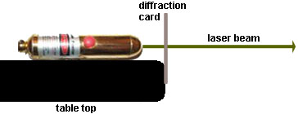

Take the diffraction card with the five portholes and tape it to the side of a tabletop, so that the portholes are just above the surface of the tabletop. Place the laser on the surface so that the beam can shine through the portholes with the 380/in mesh. Shine the beam perpendicular to a wall at a distance L. You might put a spring clip on the latter both to hold the button down and to keep it from rolling.

You’ll see a set of spots that are arranged like what you saw with the lamp. It is, in fact, exactly the same pattern! BUT, the spots will be sharp, and of one color. For the mesh gratings, you should get a compact pattern that looks something like this.

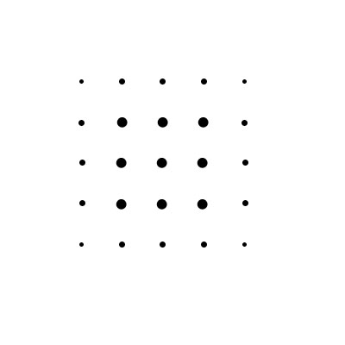

See Annex Slides 5 & 6

2. Put a white piece of paper on the wall as a screen that is big enough to show the spot separation, and carefully mark where the spots are on the paper.

Measure y – the separation of the spots.
Measure L – the distance from the grating to the screen

Using the value of d you measured for that piece of mesh, calculate the
wavelength of the laser. Remember that

tan θ = y/L

and that (with a separation of a single order difference such that n=1)

n λ = d sin θ

Measure the wavelength of the laser accurately. Yes, it’s OK to use the small angle approximation, in which sin θ ∼ tan θ = y/L.

Different kinds of lasers radiate with different wavelengths. The most inexpensive red laser pointers radiate with a wavelength of 0.65 microns. Slightly more expensive ones may radiate at 0.62 microns. If you have a green or blue laser, try that as well.

• How consistent are the wavelengths of different laser pointers?

Even among red laser pointers, students may find small differences in the wavelengths. These are a kind of laser called dye lasers, and the wavelength depends on the chemical composition of the dye. So different lasers from different batches of dye may have very slightly different wavelengths.

You may try this experiment with the CD as well, but you’ll probably have to do it in reflection, in which the laser beam is held nearly perpendicular to the surface of the CD.

Can you use a laser (once you’ve measured its wavelength) and diffraction to investigate the spacing of other periodic structures?

• Try a DVD instead of a CD. Do you expect narrower groove spacing than a CD?

A DVD holds about 4 gigabytes of data -- a lot more than a CD. So yes, you’d expect the groove spacing to be closer. In fact, a DVD holds almost exactly what the students predicted above what a disk ought to be able to hold.

• What would the spot distribution look like if the spacing of the wires that make the mesh were twice as wide in one direction as in the other?

Students should understand that for a grating with a series of holes, the direction of dispersion is parallel to the line of holes. That’s why the spots rotate when the mesh is rotated. If the holes were rectangular, the spots would be more closely spaced in one direction than in the other direction.

A fascinating sidelight on diffraction is that diffraction happens on any kind of hole. We’ve just been looking at diffraction from a row of holes! In particular, diffraction happens around edges of things. We talked about that in the engagement activity for water and sound waves. Light too actually passes around obstacles because of diffraction! We can make a plane wave diagram like we did above to show this.

In this picture, light comes in from the right, and is blocked by an edge. At each point above the edge, the light radiates outward in circles. Where there is no blockage, these circles interfere to preserve plane waves. Near the edge, they don’t.

We can use our laser to see this. Have a partner slowly move an edge (like the edge of the Diffraction Card) across the front of the laser. Go to the wall or a screen, which should be many meters away, and watch the spot carefully. Does it get cut off uniformly? No! (You’ll need to do this in near-darkness, by the way.) You can see faint light that is bent away from the main beam in the form of spikes on the otherwise round spot.

See Annex Slide 7

Diffraction is more of an everyday phenomenon than you might realize. While visible light has such a short wavelength, nothing much interesting happens unless you’re looking VERY close to the edge, longer wavelengths have larger scale effects. Radio waves are such longer wavelength light waves, and diffraction is important for us using them.

It is commonly understood that we can receive radio transmission without being in the line of sight of the transmitter. An important factor in this is diffraction, which bends some of the radio waves around obstacles. This is not just important for hills (see below), but in cities with buildings all around us. You already thought about this in the engagement activity, when we thought about how sound travels around obstacles!

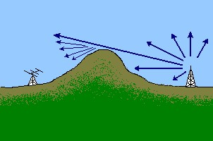

OK, we’re done with lasers. As a final quick experiment, let’s use the laser to look at the acetate grating more carefully. As noted, the grating is a set of ripples embossed on one side. Can you use the laser to tell which side? Hint – use reflection!

K. Astronomical Applications of Diffraction Gratings

Astronomers use diffraction gratings routinely to produce spectra of astronomical objects. You should understand that if you went outside and held one of our gratings up to a star, there would be spectra off on each side. But stars are so faint, and the spectra are the dispersed light from the faint star, so the spectra would be much too faint to see with the eye. (You could do it for the Sun, though!)

Astronomers use some special grating engineering to be able to take spectra of very faint stars and galaxies.

First, they use telescopes to collect a lot of light, and make these faint objects look brighter.

Second, they use reflecting surfaces for gratings, rather than transmissive surfaces. This is because even for transparent substances like our acetate 5000/cm grating, some light is still absorbed in the acetate. Even if we could make a very, very fine mesh, you can see that such a mesh would actually block a lot of the light. How do you make a reflective diffraction grating? Well, it’s a lot like the light reflected off of a CD!

1. Use a CD to look at the incandescent lamp in reflection directly with your eye, and find the main spot.

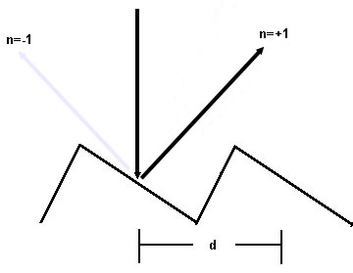

Unlike a CD though, astronomical reflection gratings have slots that are straight lines, and not circles. They are coated with a highly reflective material, to avoid losing light.

Thirdly, there is a strategy to put as much of the diffracted light as possible into one spot (n, or “order”). That’s a strategy called a “blazed” grating, where the grating is made with reflective facets that aim at the order you want to enhance.

The figure above shows two “slots” of a blazed grating, where the surface (usually of glass) is etched or grooved with facets at an angle. These “slots” aren’t really holes, like we used with the mesh, but are like individual mirrors that act like slots. Astronomers call them “grooves”. This grating above naturally reflects incoming light in the direction of the +1 order of the grating, so that order will naturally be a lot brighter than the other orders, and the starlight that hits it won’t be spread out as much among different orders.

The precision with which a grating works depends on the number of grooves that the light from the celestial object hits. The more grooves it hits, the more precise the spectrum will be, and the more detail astronomers can see in the spectrum. The most sophisticated astronomical gratings can have a million or more “grooves” or facets, all precisely parallel to each other, and precisely the same distance apart. One such reflective diffraction grating is shown in the picture below.
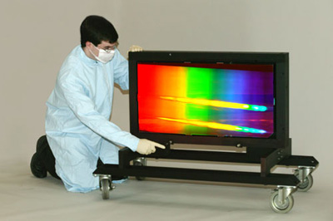

Ruling a piece of glass like this – essentially scraping it in a very precise way millions of times, is a very difficult and expensive proposition!

2. If the highest precision gratings are ones where the light hits a lot of grooves, why can’t we make a grating with d very small, so we can put a lot of grooves onto a small grating? That big grating above looks inconveniently large! Use the grating equation.

Students should understand that as d gets smaller than λ, sin θ gets to be larger than 1, whereupon the grating won’t produce a spectrum!

For most purposes, a groove spacing is chosen that is on the order of the wavelength that is going to be studied.

3. By the same token, what can we say about the sizes of gratings that would be used in the infrared part of the spectrum, compared with those that we would use in the visual part of the spectrum?

Students should know that infrared light wavelengths are much larger than visual light wavelengths. As a result, the groove separation d has to be proportionally larger. But if you need a certain number of grooves on a grating, that grating has to be proportionally larger to hold them!

History Note:
See < http://www.jhu.edu/~jhumag/0400web/02.html> for a note about early astronomical diffraction gratings.. More detail is at:
The Controlled Ruling of Diffraction Gratings by George R. Harrison

Proceedings of the American Philosophical Society, Vol. 102, No. 5. (Oct. 20, 1958), pp. 483-491.

