Virtual Design Center Facilitation For:

University of Texas at Austin astronomy team developing a high school activity to help students gain understanding of galaxies.

Team members and their projected roles:

Randi Worhatch - Science/Instructional Design
randi@astro.as.utexas.edu
(512) 232-3958

Mary Kay Hemenway - Education/Science/Instructional Design
marykay@astro.as.utexas.edu
(512)471-1309

Chris Cotter - High School Education
cottjac@sbcglobal.net
(512)841-3089

Shardha Jogee - PI
sj@astro.as.utexas.edu
(512) 471-1395

Dan Lester - Science
dfl@astro.as.utexas.edu
(512) 471-3442

Sandi Preston - Management
sandi@astro.as.utexas.edu
(512) 475-6765

A brief description of the project at the initiation of communications - October 5, 2006:
[Our objective is to] “develop a high school activity to help students gain understanding of galaxies. This will be done using images and/or data from the GEMS project on HST. We would like students to understand galaxy classifications and evolution, specifically of barred spiral galaxies, information provided by looking at galaxies in different wavelengths, and how redshift makes galaxies that are far away look red and show them to be different than present-day galaxies.” --Randi Worhatch

CET/VDC Facilitators:
Laurie Ruberg, Ph.D., Sr. Instructional Designer
Manetta Calinger, Education Liaison
Dear Randi and Mary Kay,

Manetta and I have some suggestions regarding your educational activities as you prepare to do additional classroom testing. We have enjoyed offering this facilitation service to you, but are concerned that we didn’t have time to work through steps 4, 5, and 6 of the Virtual Design Center as carefully as the first three steps. I hope this summary helps to address some of design issues that we may have passed over as the holidays and deadlines approached. I’ll use the steps of the VDC to organize my comments.

Step 1: Learner Characteristics: What specific learning goals will this activity address?
Step 2: How do your learning goals align with the standards?
Step 3: Does your investigation question motivate students? —Activate relevant prior knowledge? —Use a scientific dataset?

The introductory section of the Virtual Design Center (VDC) website contains activities to help you to understand the underlying purposes and concepts of the VDC and to plan your progress through the six steps. The basic structure of the six steps is derived from Understanding by Design by Wiggins & McTighe (2001). They suggest specifying goals and designing your assessment before planning the activities. This helps to set clear priorities and purposes of the learning activities. Here is a diagram to help you visualize this “backward design” process.

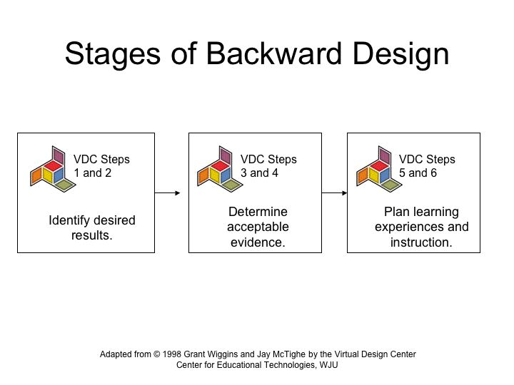

Your survey with physics, AP physics, and astronomy students gave you some concrete ideas about what topics appeared to be most interesting to students. You also learned from this exercise how the responses from the three different types of classes would differ. The preliminary survey also gave you some indication of the different levels of content knowledge and familiarity with terminology across the three groups of students. We suggest that you check your final student worksheet against your original survey findings.

Step 4: What kinds of assessments are most appropriate to measure student learning from this activity?

To expand your ideas about the kind of assessments that you could use to measure student performance for different populations of students, I suggest you refer to the discussion about using scoring rubrics for different populations of students in “Assessments in Science Education” (National science education Standards, Chapter 5: http://www.nap.edu/readingroom/boks/nses/5.html). Setting performance standards for different populations of students can help create a way to make the same activity useful for different developmental levels of students who have different experiences with science and requires different levels of sophistication in terminology and conceptual understanding. The guidelines in this chapter recommend using student responses to develop a rubric, using the responses constructed by students that illustrate exemplary verses less satisfactory responses.

We suggest that you include an assessment plan that includes concept questions, application questions, and a teacher answer sheet. To illustrate this point, below is a graphic organizer that you can use to reflect on your astronomy education activity design process learning goals, and activity design anticipated accomplishments. How far have you come in addressing each of the design questions? How close do you think you are to achieving the final design accomplishments?

Big Picture of a Design Approach (Based on the “Backward Design” approach illustrate above.)
Key Design Question | Design Considerations | Filters (Design Criteria) | What the Final Design Accomplishes
Stage 1: What is worthy and requiring of understanding? | National standards; State standards; Teacher expertise and interest | Enduring ideas. Opportunities for authentic, discipline-based work. Engaging. | Unit framed around enduring understandings and essential questions.
Stage 2: What is evidence of understanding? | Six facets of understanding. Continuum of assessment types. | Valid. Reliable. Sufficient. Authentic work. Feasible. Student friendly. | Unit anchored in credible and educationally vital evidence of the desired understandings.
Stage 3: What learning experiences and teaching promote understanding, interest, and excellence? | Research based repertoire of learning and teaching strategies. Essential and enabling knowledge and skill. | Where does the activity take students? Does it hook the students? Does it foster student exploring, rethinking, revising, exhibiting, and evaluating? | Coherent learning experiences and teaching that evoke and develop the desired understandings, promote interest, and make excellent performance more likely.

Step 5: What educational strategies best fit the scientific inquiry and learning goals for students?

Regarding Step 5 and considering what educational strategies best fit the scientific inquiry and learning goals you want to achieve, below is a table that summarizes suggested links between instructional goals and instructional strategies and relevant assessment strategies. We suggest you review the samples provided on the VDC web site showing how other teams have addressed this step. (See especially Operation Montserrat posted at http://vdc.cet.edu/step5_act2.htm)

Instructional Goals and Implications for Teaching Strategies and Assessment
Acquisition of Organized Knowledge | Development of Intellectual Skills | Enlarged Understanding of Ideas and Values
Didactic instruction | Coaching, exercises, and supervised practice | Socratic questioning and active participation
Multiple choice, matching, or fill in the blank questions | Performance assessments, lab or activity reports | Essays, oral reports, debates, student group presentations

Step 6: What science tools and educational technologies best support the learning goals of this activity?

Manetta and I have concerns about the transition of the activity from computer to paper. We understand why you see the need to do this based on teacher responses, but the skills and processes you are teaching lose their connection with real science tools. We suggest that you use the template provided in VDC Deliverable 6. (See sample completed by the Operation Montserrat on line at http://vdc.cet.edu/step6_act2.htm). Review the step 6.2 activity template as a team to discuss possible use of modeling and visualization tools and educational technology reflection (or even scaffolding) tools and how use of these tools can enhance your learning goals. By referring to the sample, completed template provided, you can see how other teams have addressed these issues.

Using the activity templates provided online in steps 5 and 6 will facilitate your team considering ways to teach about technologies used to obtain the images, embed the content and lesson in a more engaging activity, and incorporate links to image sources so that students can review and compare differences in a seamless manner as part of the flow of the activity process.

Below are some specific suggestions for revising your existing activity resources.

Teachers Guide
- Prerequisites—In cases where “students should have an understanding of…” you should explain if this understanding should results from previous, related activities, or whether these are prerequisites that the teacher must address before implementing your activities.
- Standards—The standards you list may be connected to the lesson, but they are not taught by this lesson. Those that are just connected cannot be included in this lesson.
- “Engage” discussion—This would be appropriate for a discussion on wavelengths. This discussion could serve as an introduction to the prerequisite material.
- The word “object” appears repeatedly, as in “ask the students to match objects”. The directions should specifically tell the students what they are identifying.
- Terminology—Be careful of dropping new terms and concepts without providing explanations for teachers. For example, “galaxy components”—When is this taught? (spiral arms, hot stars, gas, dust, nucleus)
- Assessment—“show the PP so students can check their results”—How is this going to work? What will they do if they get it wrong? How will the students have questions answered? This is where the suggestion above about collecting student responses as you conduct your field-testing can help you develop performance measures for different populations of students.
- “Make Connections for Teachers”—How will these activities connect to other astronomy education activities you have developed for high school teachers? If there is a logical connection, make sure teachers are aware of it—especially those who are already implementing other activities you have disseminated. Offer tips for teachers such as positioning your activities within the Texas physics and astronomy curriculum. Should this activity take place after a unit on wavelength?
- Evaluate—I recall your mentioning that the project PI’s overall goal was to get some of the best students involved in astronomy education. Use your classroom testing to find out whether these activities peak students’ interest in learning more about astronomy—that is really your ultimate goal. How will you know if you have succeeded?

Overall Recommendations
- Provide a comprehensive program to teachers, including the astronomical background material needed for teaching this unit.
- Provide or offer links to astronomy content that would help the students understand the galaxies and their features.
- Provide web links to the image sources so that students can review and compare images from different satellite, telescope, and data processing sources.
- Include a career component.
- Include a glossary.
- Include a list of resources for additional information.
- Finish the Extension section.

