Galactic Inquiry
Student Answer Sheet

Overview:
In this activity, you will view NASA images of galaxies and develop a galaxy classification scheme. Then you will compare and contrast your classification scheme to Edwin Hubble's scheme.

Before beginning this activity, you will also need the
‘Galaxies to be Classified’ Image Sheet

Directions:
Part I: Developing a Classification Scheme

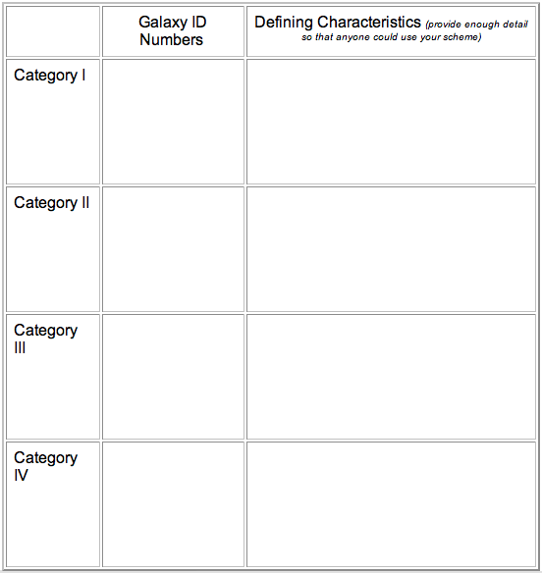
Although Immanual Kant first advanced the idea of "island universes" to explain the observed compact clouds during the eighteenth century, it wasn’t until this century that astronomers began to develop an understanding of the nature of galaxies. Your instructor will provide you a sheet with fifteen galaxy photographs. Your first task is to sort the galaxies by creating and applying a classification scheme based on appearance. Complete the table below.

Part II: Applying Hubble’s Classification Scheme

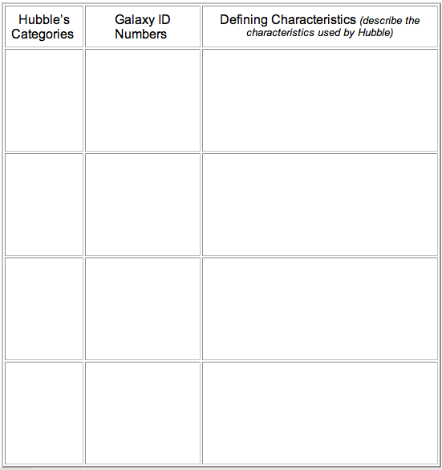
After you have completed Table 1, ask your instructor for a copy of Edwin Hubble’s classification scheme, which was developed in the 1920’s. Complete the following table using his scheme.

Reflection Questions to Answer:

Question 1: Unless there is an underlying model, classification systems are completely arbitrary as long as the defining characteristics are clear to everyone. Which of the two systems, yours or Hubble’s, does your group prefer? Why?

Question 2: Hubble viewed the tuning fork diagram as representing an evolutionary sequence for galaxies. Using the tuning fork diagram, propose an evolutionary sequence for galaxies.

Question 3: Astronomers now realize that the tuning fork diagram does not represent an evolutionary sequence. Does this mean that Hubble’s scheme is useless? Explain.

