Multiwavelength Astronomy: Your World in a Different Light

Introduction
What would it be like if you were colorblind? How much information would you fail to receive from the world around you? You would probably have difficulties identifying types of apples, for instance. If you could not tell the difference between yellows, reds, and greens, how could you begin to sort a pile of apples by variety?
In a way, all humans are colorblind. We’re colorblind to colors like ultraviolet and infrared and for everyone except Superman, we’re colorblind to X-rays. People just cannot see those wavelengths of light, and since that is what defines colors, we can think of these ranges of the electromagnetic spectrum as extreme colors. These colors include gamma-rays, X-rays, ultraviolet, infrared, microwave, and radio, while our eyes can only see the usual ROY G BIV variety.
Take a look at the following image. Note what a tiny portion of the spectrum is actually made up of colors we can see (visible). How much more could we learn about the world and the universe if only we could see in those other wavelengths?

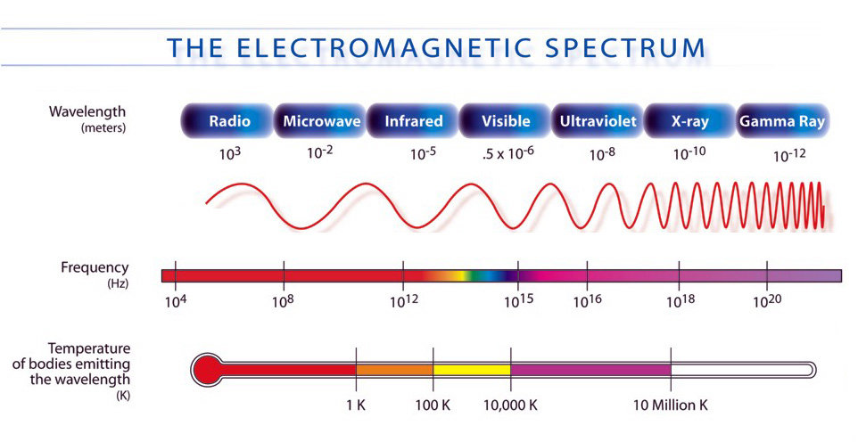

So how can we see in these other wavelengths? Well, with our naked eyes, we can’t. However, we can build instruments and sensors that are sensitive to these colors and represent them in a way that we can still interpret. This is where false-color imaging comes in...

False Color?

Look at the two images on the slide show of a dog that were taken in the infrared. These are two versions of the same image, with the same scale of temperature, but the right picture has a larger range of colors to show the same range in temperature. When there are more colors in the same temperature range, you can easily detect more detail about small temperature differences.
Of course, the dog isn’t actually purple. The people who make images using invisible wavelengths, such as infrared, choose the visible colors to represent those wavelengths. They try to make the information useful at a glance, like in these pictures.

Which areas on the dog are hottest? __________________________________________

Which are coolest? _______________________________________________________

When you look at a dog in visible light, can you tell which areas are hottest and coolest just by looking?

_______________________________________________________________________

X-Ray Challenge
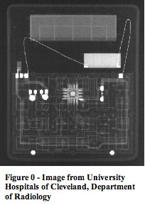
Maybe you’re not Superman, but using the right equipment, anyone can see in X-rays. The X-ray wavelength is so small that it only interacts with dense matter on Earth, like metal or bone.
If you put an object in between an X-ray emitter and an X-ray detector, you can see where the dense materials are located (shown as white in this picture).
This picture was taken with the object still sealed, so the X-rays are penetrating through the outer part we would normally see. What do you think this object is?

_____________________________________

_____________________________________

What are the bright areas highlighting?

_____________________________________

____________________________________
Wien’s Law
Where Do All Of These Different Wavelengths Come From?

Right now, every object in the room around you is emitting electromagnetic waves…your shoes, your chair, the wall, even you…Everything is radiating! Anything with any heat energy whatsoever radiates electromagnetic waves. The only way an object could not emit radiation is if its temperature were absolute zero (0° Kelvin, or about -460° Fahrenheit). But the laws of thermodynamics tell us that it impossible for something to get that cold, so you can correctly say that every single object in the entire universe is emitting electromagnetic waves!

Some objects are better emitters than others. For example, a light bulb filament will emit radiation much more efficiently than a pencil eraser. Stars happen to be some of the best emitters around; they are very close to being perfect emitters (which physicists call black bodies).

Most objects, especially stars, will emit electromagnetic waves in almost every possible wavelength, from gamma rays all the way to radio waves. But each object will emit significantly more radiation in some wavelengths compared to others. The wavelength where an object emits the most radiation is called its wavelength of maximum intensity. The wavelength of maximum intensity doesn’t really depend on what the object is made of…So, what does it depend on? TEMPERATURE!

In fact there is a nice, simple law of physics that describes the relationship between the wavelength of maximum intensity and temperature.

It’s called Wien’s Law: λmax (nm) = 3,000,000 (K⋅nm) nm - nanometers
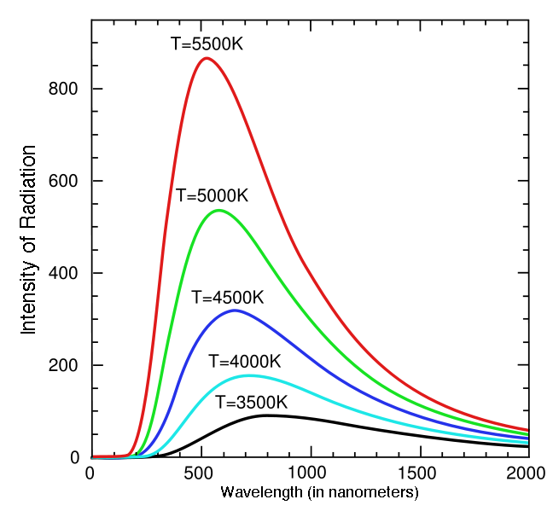
Temperature (K) K - Kelvin

Look closely at where the peak of each curve is.

Do hotter objects give off their maximum radiation at shorter or longer wavelengths?

__________________

This graph shows the radiation curves for some temperatures that you can relate to:

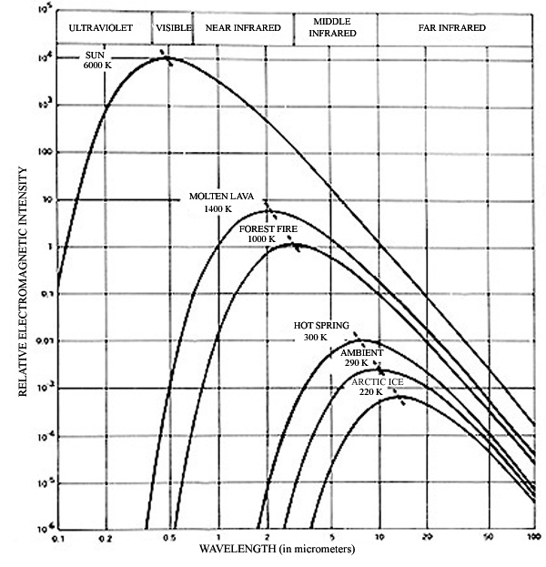

Where do you think extremely hot young stars (100,000°K) emit most of their radiation?
(circle one)
Ultraviolet Visible Infrared Microwave Radio

Have you ever noticed your doctor taking your temperature by pointing an instrument in your ear for a split second? Well, that instrument is an infrared detector that finds your wavelength of maximum intensity and then converts it into your body’s temperature. It is a perfect example of utilizing Wien’s Law.
How Does All of This Relate to Galactic Astronomy?

When astronomers first started looking at galaxies, they could only see them in the visible wavelengths. From what they saw, they were only able to describe galaxies in the most basic way: large collections of stars, sometimes with a spiral structure. They couldn’t understand much more than that.
Now that we have the technology to detect other wavelengths of light, we are finding out all sorts of fascinating information about what galaxies are made of, how they evolve, which parts are the most active, and much more. As we just learned, each wavelength can show us objects that represent specific temperatures. The table below puts it all together:

Type Of Radiation | Characteristic  Temperature | Objects Emitting This Type of Radiation
Gamma rays | more than  10⁸ Kelvin (K) | * Pulsars or Neutron Stars  * Accretion disks around black holes  * Interstellar clouds
X-rays | 10⁶-10⁸ K | * Regions of hot, shocked gas  * Gas in clusters of galaxies  * Neutron stars  * Supernova remnants  * Stellar corona
Ultraviolet | 10⁴-10⁶ K | * Supernova remnants  * Very hot stars  * Quasars
Visible | 10³-10⁴ K | * Stars  * Galaxies  * Reflection nebulae  * Emission nebulae
Infrared | 10-10³ K | * Cool stars  * Star Forming Regions  * Interstellar dust warmed by starlight  * Planets  * Comets  * Asteroids
Radio | less than 10 K | * Cosmic Background Radiation  * Scattering of free electrons in interstellar plasmas  * Cold interstellar medium  * Regions near white dwarfs  * Regions near neutron stars  * Supernova remnants  * Dense regions of interstellar space (e.g. near the galactic center)  * Cold, dense parts of the interstellar medium - concentrated in the spiral arms of galaxies in molecular clouds (often the site of star formation).  * Cold molecular clouds
Table courtesy of NASA/JPL-Caltech
Galaxies in a Different Light: Matching Activity - Student Answer Sheet
Instructions: In this activity, you will have three sets of cards with images of galaxies. Each set is comprised of images taken in a certain wavelength. So one set is visible light images, one is ultraviolet images, and the other is radio images. The same eight galaxies are represented in each wavelength. After matching different pairs of images, record your matches in the charts provided. In the last column, describe why you chose to pair each match in the way you did. Be as detailed as possible in your descriptions.
---Note: To save ink, the card images are negatives of the real pictures (black and white are reversed). The darkest spots on the cards represent the brightest parts of the galaxies. This saves ink. Also, it is often easier to see more detail in negative images.
Match the set of VISIBLE images with RADIO images.
DO NOT match the Ultraviolet Cards yet.
(A sample answer has been shown in the chart)
Visible | Radio | Reasoning
90 | Z | spiral arms extend clockwise, matched features on upper left, same orientation
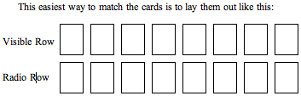

Now put aside the radio images. Match the VISIBLE images with ULTRAVIOLET images.

Visible | Ultraviolet | Reasoning

Now match the RADIO images back with the VISIBLE-ULTRAVIOLET
pairs so that you have sets of three, where each set is the same galaxy.

Visible | Ultraviolet | Radio | Reasoning

Now look at the slide show to check your answers and revise your sets.

Assessment Challenge
Look at the slide: For each numbered picture, guess which wavelength the picture represents, and write three galaxy features that are likely to be seen in that wavelength:

 | Wavelength | Galaxy Features Represented
1
2
3
4
5
(Tear this page off if you’d like to hold on to it)

-To see more awesome pictures like the ones in the slide show, and to find out even more about the telescopes involved in capturing them, please visit NASA’s CoolCosmos website:

http://coolcosmos.ipac.caltech.edu//

-To learn about the history of telescopes and the evolution of astronomical technology, please visit the Space Telescope Science Institute’s website called Telescopes from the Ground Up:

http://amazing-space.stsci.edu/resources/explorations/groundup/

-To find a local astronomy club in your area, please visit:

http://nightsky.jpl.nasa.gov/club-map.cfm

Telescope Source Information for Images on Galaxy Cards
ASTRO-1: these images were gathered from telescopes mounted on board a Space Shuttle. Three different ultraviolet telescopes were mounted in the payload of the Space Shuttle Columbia and made 231 observations over a 9-day period (Dec. 2nd-11th, 1990)

ASTRO-2: a follow-up project to ASTRO-1, these images were also gathered from telescopes that were carried on board a Space Shuttle. This time, the same three UV telescopes were mounted on the Space Shuttle Endeavour. They made several hundred observations over a 16-day period (March 2nd-18th, 1995), which set the record for the longest shuttle mission at the time.

GALEX: The Galaxy Evolution Explorer (GALEX) is an orbiting space telescope that observes galaxies in ultraviolet light across 10 billion years of cosmic history. With sensitive ultraviolet detectors, a large field of view, and its location above the ultraviolet-absorbing atmosphere of the Earth, GALEX is able to do one-of-a-kind observations, including an extra-galactic all-sky survey.

NRAO: The National Radio Astronomy Observatory is an organization that designs, builds and operates the world's most sophisticated and advanced radio telescopes. They gather info from hundreds of radio telescopes from all around the world working in unison. Radio telescopes are typically very large dishes (like in the movie Contact, which has scenes filmed at a the VLA [see below] and at the 1,000 ft. Arecibo telescope in Puerto Rico – the largest in the world).

VLA: The Very Large Array, one of the world's premier astronomical radio observatories, consists of 27 radio antennas in a Y-shaped configuration on the Plains of San Agustin fifty miles west of Socorro, New Mexico. Each antenna is 25 meters (82 feet) in diameter. The data from the antennas is combined electronically to give the resolution of an antenna 36km (22 miles) across, with the sensitivity of a dish 130 meters (422 feet) in diameter. Most people will recognize from the movie Contact. It is operated by the NRAO.

NVSS: The NRAO VLA Sky Survey (see above) is a huge survey of the sky done in radio wavelengths. Completed by the NRAO using the VLA, the information gathered is provided free to the entire astronomical community to help advance science.

RAIUB/MPIFR: The Radio Astronomical Institute of the University of Bonn and the Max-Planck-Institute for Radio Astronomy are German institutions that use a 100-meter radio telescope located in a protected valley in western Germany (near Effelsburg). The combination of the high surface accuracy of the dish and the construction principle of 'homologous distortion' enables observations at unprecedented high frequencies for such a large telescope. The telescope can be used to observe radio emission from celestial objects in a wavelength range from 73cm (408MHz) down to 3.5mm.
Effelsburg: see above (RAIUB/MPIFR)

AAO: The Anglo-Australian Observatory, located in Australia, houses a 4-meter equatorially mounted telescope. Its excellent optics, exceptional mechanical stability and precision computer control make it one of the finest telescopes in the world. Like most telescopes, the AAT can be used in many configurations, each requiring a different instrument or detector to collect and analyze the light. Most astronomers use charge coupled devices (CCDs) to collect data. These highly sensitive solid-state devices convert feeble light into digital signals which are then collected and stored on computers for further analysis, rather like an electronic photograph.

Grasslands Observatory: this is a small, privately owned, observatory located in Southeastern Arizona. It houses a 24-inch reflecting telescope that is well suited for optical astronomy.

IAC/RGO/Malin: This image was actually taken using the Isaac Newton Telescope, located in La Palma, Spain. It has a 100-inch primary mirror.

KPNO: The Kitt Peak National Observatory is located near Tuscon, Arizona. KPNO has 19 optical/infrared telescopes and two radio telescopes onsite. It supports the most diverse collection of astronomical observatories on Earth for nighttime optical and infrared astronomy and daytime study of the Sun. The visual image from KPNO used in this activity was taken on a 0.9 meter telescope.

The other images were taken by amateur astronomers whose info is not available – Amateurs help out a lot!

