Multiwavelength Astronomy: Galaxies in a Different Light
Teacher Edition grades 9-12

Introduction:
Throughout this activity students should begin to realize that there is a wealth of information that we can learn about many objects in nature even if we can't see it with our own eyes. Students will review basic concepts about the electromagnetic spectrum, and then learn about false-color imaging, Wien’s law, and galactic astronomy. They will combine all of this knowledge to see how observing galaxies at different wavelengths enables astronomers to gather huge amounts of fascinating information about galactic structure and composition. Visually inspecting the multiwavelength images should enable students to recognize the variety of “hidden” information that can be gathered from looking at more than just the visible part of the spectrum. For instance, while some galaxies have features that are obscured by dust in visible light, the infrared images show the light the dust emits and what may be concealed inside of it. Or they may see that X-ray and radio observations give astronomers a means of seeing large-scale structure that may not be visible in ultraviolet, visible, or infrared.

Prerequisites:
Prior to this activity, students should have a basic understanding of the electromagnetic spectrum, i.e. that radio, ultraviolet, x-rays, etc. are all forms of light with different wavelengths/energies, and because they are light, they all travel equally fast at the speed of light. This subject matter is not addressed in the previous scaffolding activity (see below), but is a necessary prerequisite knowledge base that should be taught prior to conducting the activity.
Recommendation: Before doing this activity, do prior scaffolding activity: The NASA Ceres Project Galaxy Classification Activity found at http://btc.montana.edu/ceres/html/Galaxy/gal1.html. The activity covers different types of galaxies and how they are classified. If you are doing this (Multiwavelength Astronomy) activity alone without proceeding to the next activities in the Building Bridges Galaxy Evolution scaffolding, then the Galaxy Classification activity is not necessary, but still recommended.

Estimated time for activity: 90 minutes --- (Optional: to save classroom time [~15-20 minutes] the coloring activity “False Color Galaxies” may be assigned as homework to be completed the night before.)

Student Product:
In pairs, students will answer questions in the student guide and complete a short coloring activity. Students will also match galaxy images taken in different wavelength regions and fill out the corresponding tables, which include providing justification behind their reasoning. After the activity, students should understand there is important information gained by observing galaxies (or anything) in different wavelengths and some of the galaxy features emit in those wavelengths.

Materials:
- multiwavelength.zip file
- computer for classroom with internet browser (no connection necessary once file is downloaded)
- projector connected to computer
- Standard Image Set, one for each pair of students
- Student worksheets "Multiwavelength Astronomy: Your World in a Different Light", one 9 page worksheet for each pair of students
- Student coloring activity sheet “Multiwavelength Astronomy: False Color Galaxies”, one 2 page worksheet for each pair of students
- Markers: (blue, green, yellow, pink/orange/red) 1 set for each pair of students

Standards:
NSES:
- Physical Science- Interaction of energy and matter.
- Science and Technology- Understanding about science and technology.

TEKS:
- 112.42 - 2C, 2D, 5C
- 112.47 – 2C, 2D, 8B, 8C
- 112.48 - 2C, 2D, 4B, 5C

Teacher Preparation:
Teacher must print and cut out the galaxy images from the Standard Image Sets. Recommended: print on card stock; print with low toner to enable students to see details – printing with normal toner levels makes contrast on the cards too extreme.
- Standard Image Set: Print enough copies for each pair of students to have one entire set. Cut the image cards apart. The images will be sorted as per the following instructions. All images have a label below them indicating the wavelength of the image. Sort the cards by wavelength so there are three subsets of images – visible, radio, and ultraviolet.
- Teacher must also download the Answer Guide zip file and unzip it. In the classroom, have a computer available and provide a projection system* for the class to check answers simultaneously. The Answer Guide is also used while the students fill out the Student Worksheet.
- Optional: Download and print the coloring portion of the activity (“False Color Galaxies”) and give to students to complete as homework the night before. This will save about 15 minutes of classroom time.
- PLEASE READ THROUGH THE ENTIRE ACTIVITY AND TEST THE POWERPOINT SLIDE SHOW BEFORE PRESENTING TO THE CLASS

Appendix:
For teachers without computer projection capabilities, please download and print the three pages that have the color images needed for filling out the Student Worksheet. Teachers can print these pages as a transparency for the students to view while filling out the Student Worksheet.
However, students should be given a chance to view all the color images in the Answer Guide to enhance comprehension, even if the teacher cannot project them. Doing this gives the students a chance to extend their knowledge by viewing infrared and X-ray wavelengths of many of these galaxies as well. The powerpoint slideshow for this activity can be found at http://outreach.as.utexas.edu/marykay/galaxy/galaxy.html
DO NOT give this web address to students! But you can download the powerpoint file and pass that on to them if they’d like to see more on their own computer later.

TO BEGIN:
Group students into pairs, then pass out one Student Worksheet "Multiwavelength Astronomy: Your World in a Different Light" to each pair.

Engage:
*Project the first slide of the Answer Guide.
Begin by asking students what different wavelengths can tell us about things in the real world. Students may answer that infrared is heat so you can tell how hot something is, or that people use x-rays to see inside the body/luggage. Give the example of a doctor trying to learn more about you because you're sick. What wavelengths do doctors use? Visible light - they look you over on the outside; infrared - they take your temperature; X-rays - used to see through your skin/deeper inside you. If you are very ill, they may use an MRI (radio wave), or treat a cancer with gamma rays.
* Teachers without computer projection systems see Appendix.
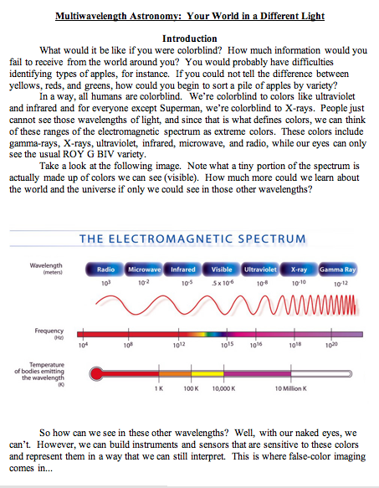

Explore:
Instruct the pairs of students to read page 1.

When everyone is finished reading, continue to the next page…

Explain:
*Project the second slide: “Infrared Dog”
Instruct the students to read along and answer the questions on the top of page 2 of the worksheet while projecting the second slide of the Answer Guide, “Infrared Dog”. Point out that the dog is actually emitting the infrared radiation, as opposed to reflecting it (it would be reflecting in a visible light image).

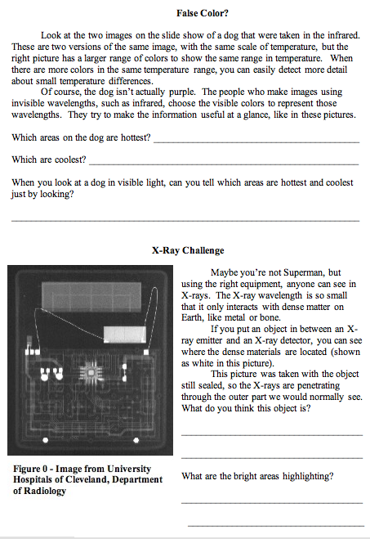
Answers: The hot areas of the dog are the ears, eyes, and mouth. The cold areas are the areas insulated by fur and the nose. After students have answered on their sheets, ask the class what they thought the answers were and discuss why this makes sense. Infrared senses hotter areas, so the bright areas are the areas that open to the interior of the dog’s body, while the cold areas are insulated and far from the center of the dog, except the nose, which is kept wet and cold.

*…after students have answered the Infrared Dog questions, project slide three: “X-ray Challenge”
Have the students read through the bottom of page 2 and answer the questions.
The mystery object is a pocket solar calculator. The bright areas are the circuitry (the denser materials).
This image is made by emitting X-rays through the calculator, and then catching the remaining radiation on the on the other side (usually with film). The bright areas are those that reflect the X-rays, hence the rays don’t make it to the film. The dark areas are where the X-rays made it all the way through without being reflected by any dense material. (Note: astronomers usually utilize X-rays in a different way…they are interested in the object that is emitting the radiation, not so much in what is in between. This picture is only used to emphasize the idea that scientist can detect “hidden” objects by looking at different wavelengths.)

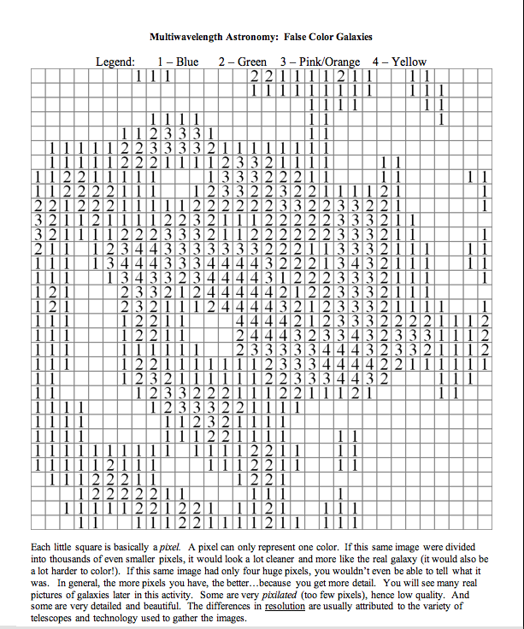

Pass out the “Multiwavelength Astronomy: False Color Galaxies” sheets.

***Note: This coloring activity can be assigned as homework to be done the night before the activity***

Each group should get both pages 1 and 2. Pass out markers so each pair has the 4 colors.

Have each student take a sheet and color according to the legend. Students may realize while coloring that their picture does not match their partner’s. This is intentional.

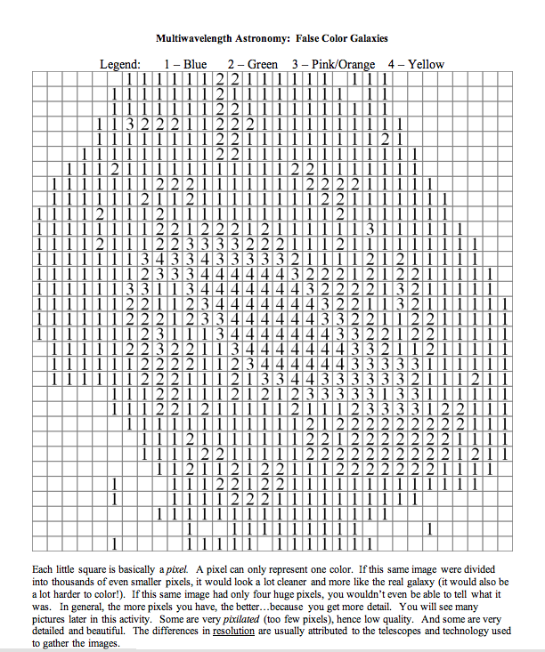
After students have filled in the sheets using markers, explain that both members of each pair have an image of the same galaxy. The image on page 1 is from the radio band, and page 2 is in the visible. Stress that the differences are due to different details seen in different wavelengths. This is how astronomers get more information by looking in different wavelengths. Sometimes they see structures that were not observable in other wavelengths. Have students note details visible in one wavelength and not the other.

The students should also read the short paragraph about pixilation and resolution at the bottom of their sheet. (The exact same paragraph is on both pages).

*Project slide four: “Wien’s Law”
Have the students read through pages 3 and 4 of the Student Guide and answer the questions.
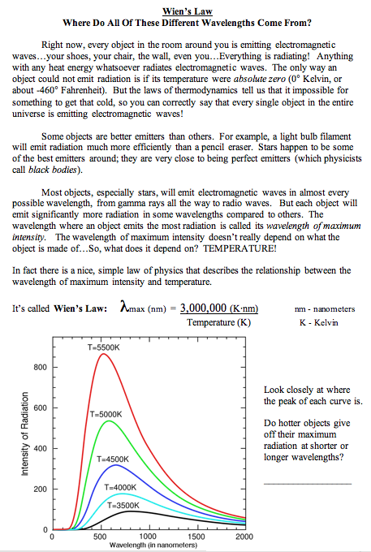
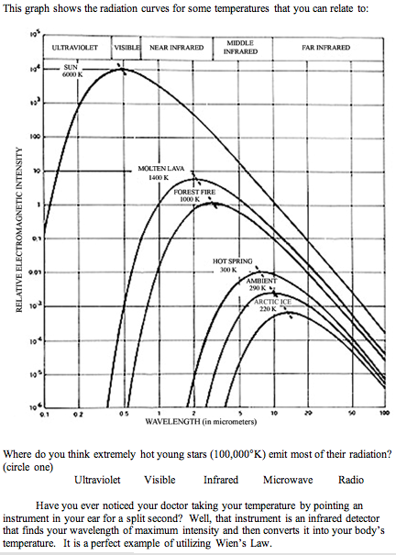
Answer to question on page 3:
Hotter objects give off their maximum
radiation at shorter wavelengths.

Answer to question on page 4:
Hot young stars (100,000 K) emit most of their radiation in the Ultraviolet part of the electromagnetic spectrum.

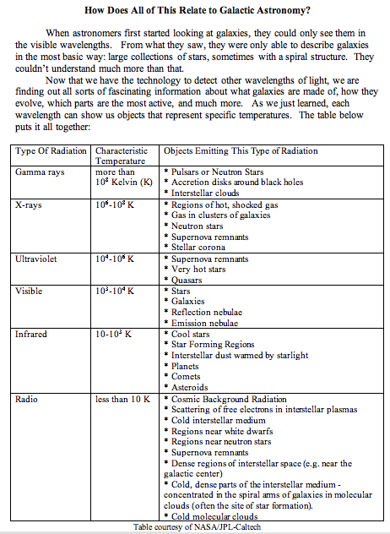
*Project slide five: “Galaxy Features”

Have the students turn to page 5.

Talk through the slide and the chart with the students.
Explain that specific parts of a galaxy emit light in different wavelengths. When astronomers take images that are in different wavelengths, they see the features that emit light there. In order to view the differences, astronomers use "false colors" (similar to the dog images) to denote different wavelength regions.
For instance, ultraviolet images highlight areas of the galaxy where there are hot, young stars. For spiral galaxies, this is often in the spiral arms. In visible wavelengths, these stars appear blue. Most stars in general are seen when viewed in visible light, this includes stars like our sun. The nucleus (core) of a spiral galaxy has more evolved (cooler and older) red stars. In some visible images, astronomers see dark areas caused by dust that block the light coming from behind; since the dust emits light in the infrared, astronomers can detect structures, using infrared observations, that are sometimes obscured in the visible. X-rays indicate very hot gas in and around the galaxy (false colored as yellow/orange in the slide), along with very energetic stars (green). Cool gas in the galaxy emits radio radiation. Knowing these features match certain wavelengths, astronomers can better determine the structure of the galaxies in the images.

Elaborate:
*Project slide six: “Multiwavelength Astronomy”

Matching sets of image cards activity (pages 6,7, & 8 of the Student Guide)
(An important thing to note is that the images of each galaxy are all of the same orientation and scale, as you may see in these examples that can be inspected via the Power Point Answer Guide:
-Orientation: the x-ray image of M82 (slide 12) really is showing matter at right angles to the plane of the galaxy seen in the other images.
-Scale: M100 (slide 8) -In the ultraviolet images looks as though it could be a zoom-in of the center of the galaxy, but it is not. The crescent shape doesn't seem to strictly match the spiral arms, and yet the size and orientation of this image is the same as the others.)
The images on the cards are negatives of the real pictures (black and white are reversed). This saves ink and results in crisper, longer lasting images.
- Pass out, to each pair of students, the RADIO and VISIBLE card sets from the Standard Image Set. DO NOT pass out the Ultraviolet cards yet.
- Have each pair designate one of themselves as a data recorder. This student will write their data on the answer sheet.
- Ask the pairs of students to match the image cards so each visible card has a radio mate. There should be eight image card pairs. This works best when students line up the eight images from one set across the top of their desks, then match the corresponding image cards below. Then have the data recorder write down their answers on page 6 of their worksheet and justify their decisions in the “Reasoning” column. Give students a time limit for each matching set. 5-6 minutes is suggested, no more. DON’T GIVE THE ANSWERS YET
- Have students put aside the radio image set. Pass out the ULTRAVIOLET card set. Ask students to match the image cards in ultraviolet and visible, so there are eight pairs, each with a visible and ultraviolet image card. The data recorder should record answers and reasoning on page 7 of the student worksheet. Give students the 5-6 minute time limit for matching and recording.
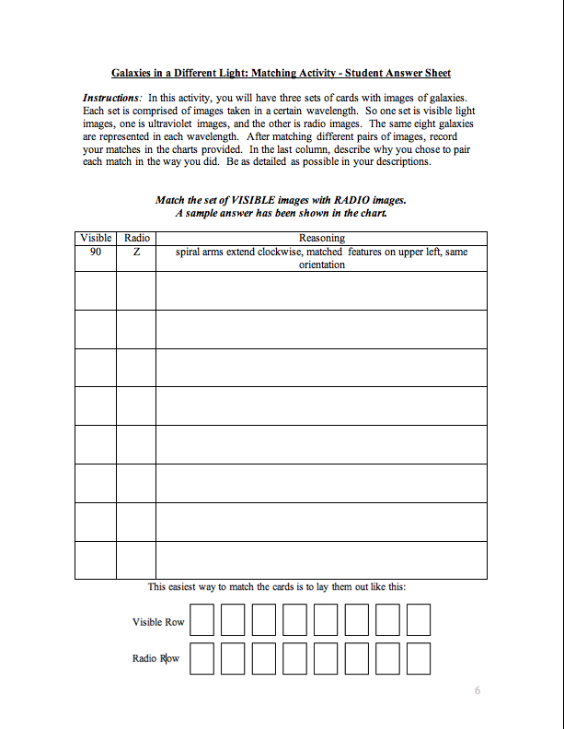
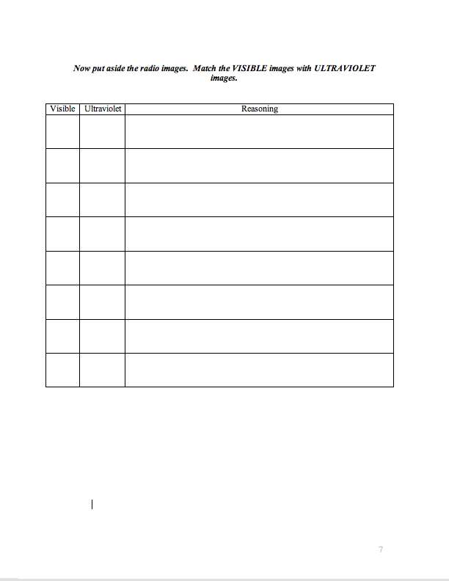
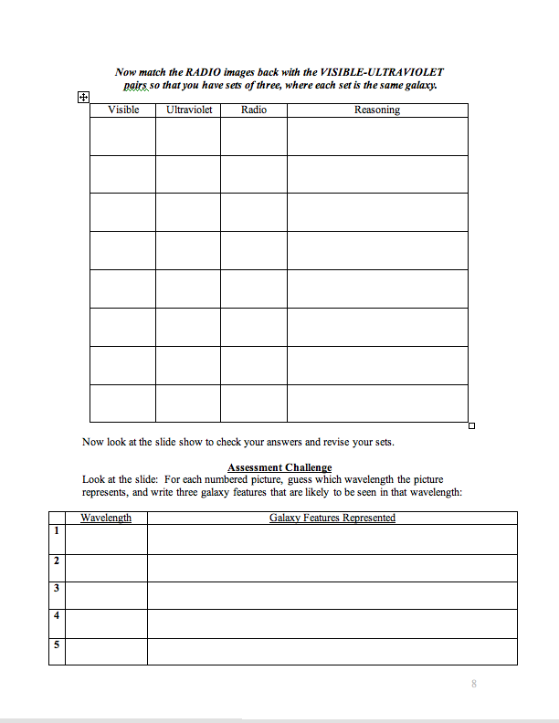
- Leaving the visible-ultraviolet matches out on the desk, have students then get out their radio image card set and match them so that for each galaxy, there are three images – one in visible, one in radio, and one in ultraviolet. Have the data recorder record their answers on page 8. Give students a 5-6 minute time limit.

Discuss which wavelengths were the least similar (hardest to match) and why. Students may respond radio and ultraviolet. These two wavelengths are the farthest apart in the electromagnetic spectrum (out of the three they were asked to match). Also, many pictures have poor resolution and are highly pixilated (especially in the radio band). This is usually due to differences in telescopes used to gather the images. Ask students if different parts of a galaxy are seen more easily in some wavelengths than others (e.g. spiral arms, core, dust, gas, stars).

ANSWERS to matching activity:
*Project slide seven and onward. Stop at “Assessment Challenge.”
Show the Answer Guide slides one at a time so that students can check their results and rearrange, if necessary. This should be a chance for students to assess themselves in their logic for matching, but also revise and rethink their answers. Seeing the color images should also solidify why certain image cards matched, especially when details are lost in the printing.
Below is a table of the correct results:
Visible | Ultraviolet | Radio | Galaxy Name
1 | VII | C | M94
2 | IV | A | M100
3 | III | G | M31
4 | II | H | M101
5 | VI | D | M33
6 | I | F | M82
7 | V | E | M81
8 | VIII | B | SMC

If you wish to review galaxy types, here is a resource list.:
TYPE | Examples
Irregular | Centaurus A, Small Magellanic Cloud, Large Magellanic Cloud, M82
Elliptical | M84, M87
Spiral | M31, M33, M65, M74, M77, M81, M94, M100, M101, M104, M106
Barred Spiral | M83, NGC 1313

Evaluate:
*Project slide fourteen “Assessment Challenge.”
Have students examine the slide and discuss with their partner which galaxy features are emitting in each image. This will have the students consider which wavelengths the images are taken in based on the features they can notice. Students should be remembering the discussion of the “Galaxy Features” slide and applying their understanding of different wavelengths based on the matching they did. They can also refer back to the chart on page 5. There is a table to record answers at the bottom of page 8 of the student guide.

Students will guess the wavelength, and write three galaxy features that are related to that wavelength.

Answers:
1) Infrared
2) X-Ray For each wavelength, they should write at least three corresponding features
3) Visible that are listed in the chart on page 5 of the student guide (page 7 of the teacher
4) Ultraviolet guide). Guessing the correct wavelength is not important, but listing the correct
5) Radio features for their chosen wavelength is important.

At this point, mention to students that professional astronomers will look at these pictures and notice very different features than the students: When looking at pictures such as these, experts will instantly notice what is relevant and important scientific information, while novices (e.g. the students) will tend to focus on somewhat irrelevant features.
For example, in the ultraviolet picture (#4 on the current slide), novices might notice that there are three bright dots and a hazy blob shape. A professional astronomer at the University of Texas recently looked at the exact same picture, and he instantly knew which galaxy it was (M82). He quickly dismissed the bright dots as irrelevant foreground stars. He then began discussing how the UV image highlights the newest star-forming regions of the galaxy, which would likely be distributed along the spiral arms if we could see this galaxy face-on. He also mentioned that it is obvious that there is a huge amount of extinction (dust blocking out the light) that contributes to the apparent irregular shape of the galaxy.

Extend:
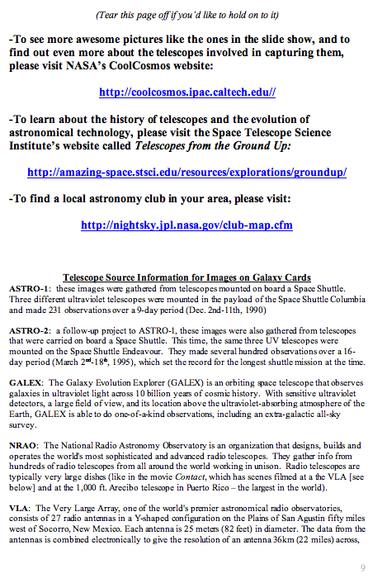
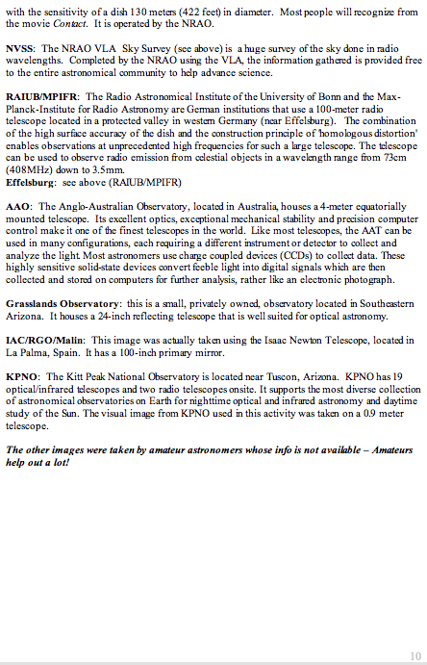
The last two pages (pgs. 9 & 10) of the student guide refer the students to three different websites that they can visit to follow-up on any interests or questions they have about the galaxy images and the telescopes used to gather them. There is also a list of some of the telescopes used to gather the images, with short descriptions of each. The students can tear this last page off and take it home.

*

