Teacher Guide

Lives of Stars
An Interview with Several Stars in the Milky Way
(5 Billion years in the Future)

Introduction
This activity is an opportunity for students to learn about the fundamental characterisitcs of stars and their life cycles. Students perform a play as members of an interview with several different stars. As the play progresses, students develop an understanding of the most fundamental concepts in stellar astronomy. The most important ideas are repeated through out the play. At the conclusion of the activity, students will have an understanding of the main three types of stars (red, yellow, and blue stars) and the ways in which these stars differ as they progress through their various stages of life and death.

A star, like our Sun, is an enormous and complex system. In order to model and understand their properties and how they change with time, astronomers and astrophysicists apply the basic ideas in physics to mathematically model a star. Astronomers then use telescopes and other instruments to find observable clues to test these models. The current theory of stellar evolution is based on mathematical and computer models of stars, and are very well supported by a wide variety of astronomical observations of every sort of object in the sky such as stars, galaxies, black holes, supernovae, and nebulae.

TEKS
112.42 IPC
6. The student knows the impact of energy transformations in everyday life.
A. describe the law of conservation of energy.
8. The student knows that changes in matter affect everyday life.
D. describe types of nuclear reactions such as fission and fusion and their roles in applications.

112.47 Physics
5. The student knows that changes occur within a physical system and that energy and momentum are conserved.
B. observe and descibe examples of kinetic and potential energy and their transformations
6. The student knows forces in nature.
A. identify the influence of mass and distance on gravitational forces.

112.48 Astronomy
6. The student knows the characteristics and life cycle of stars.
A. describe nuclear reactions in stars.
B. identify characteristics of stars such as temperature, age, relative size, composition, and radial velocity using spectral analysis.
C. identify the stages in the life cycle of stars by examining the Hertzsprung-Russell diagram.
7. The student knows the role of the Sun in our solar system.
A. indentify the approximate mass, size, motion, temperature, structure, and composition of the Sun.

Duration
The reading of the interview and the completion of the evaluation questions should take about 1 hour of engaged work if it is done quickly. If more time is needed, you may want to assign some of the questions as homework.

The Cast
Page the photon reporter: an energetic but sensitive photon journalist who is interviewing the Sun for her column in the Local Group Times.
Sol the white dwarf: a kind and friendly star, our Sun at the end of his life. Sol used to be a yellow star. This interview takes place about 5 billion years into the future, when the Sun becomes a white dwarf.
Apollo the blue star: a young bragging and self-aggrandizing star that is full of youthful energy.
Kronos the red star: an old, experienced, and somewhat irritable star who has been around since close to the beginning of time.
Iana the interstellar cloud: stars begin their lives as collapsing globs of gas inside an interstellar cloud or nebula.
Minerva the Red Giant: Minerva is in the next phase of life - a bloated red giant star. Her size could easily swallow up Mercury and Venus and almost Earth.

Assign Roles
Sol and Page have the dominant roles, Apollo and Kronos have many lines, Iana and Minerva have very small parts. There are two possible ways to assign roles…

Individual parts: Each of the six characters can be played by an individual student.
or
As a whole class: This method helps ensure that all students will pay attention. Students in turn, play/read the parts of the characters. Divide the students into groups. Each group will be a different character. Try to make the groups of different skill levels. Each student in each group will take turns reading so that everyone has to read and follow their script.

Ask Guiding Questions
As students act out the interview, ask guiding questions to focus students’ attention on physics or chemistry concepts. For instance, as Sol is contracting under his own weight and getting hotter during his protostar stage, ask students to think about the ideal gas law.

Pressure × Volume = Number of particles × k × Temperature of the gas
PV = NkT

$\frac{\text{Force}}{\text{Area}}$= Pressure = $\frac{N}{V}\text{kT}$

In a star, the pressure changes with radius. This changing pressure is what holds a star up, keeping it from collapsing. At each layer, the outward push of the gas is balanced by the inward pull of gravity on the gas.

Example:
If the core shrinks, its volume decreases. For the pressure to balance out the force of gravity, the temperature must go up. It’s like a bicycle pump. Compressing the air inside the pump raises the temperature of the gas. That’s why the pump feels hot after doing the work to inflate a bicycle tire.
Before beginning the interview, it may be helpful to review the following:

Key concepts and terms:
Speed of light | Potential energy
Scientific Notation | Kelvin
Nebula | Luminosity
Light year | Magnitude
Galactic year | Proton
Planetary nebula | Electron
Conservation of Energy | Positron/neutrino
Kinetic energy | Hydrostatic equilibrium

Recommended Preparation:
Review vocabulary. Review Scientific Notation and distance measurements in space. Put up photos (usually downloaded from web sites and/or posters) of a star field with multiple colors of stars, a red giant, the sun, a nebula, a supernova, a dying star like Eta Carinae, etc. The more photos that can cover the chalk boards, walls, doors, ceiling, the better but do not put them up until the day of the interview.

***Beginning the Activity***

Engage
Read the following to students:
“Our galaxy, by conservative estimates, contains 100 billion stars. The small number of stars we can see at night are the nearby stars in our tiny neighborhood of our galaxy. Stars are not eternal, but live long lives compared to our lifetime. Over time they change. Just like you can look at a family photograph and tell who is young or old, astronomers can observe stars to estimate their stage of life.”

Pass out one 3 x 5 inch index card to each student.
Ask students to write about what physical processes they think are going on inside a star like our Sun. Tell them that grammar, punctuation, spelling, etc. does not count. Drawing is fine. But they must be writing or drawing for 2.5 minutes without stopping. Students can ask for additional index cards.

Ask students to share their responses. Summarize the responses on an overhead projector for everyone to see.

Review the students’ responses. Help students identify the ones related to forces, motion, conservation of energy, gas laws, and nuclear fusion. Tell students to keep these concepts in mind as they act out and discuss the interview with a white dwarf.

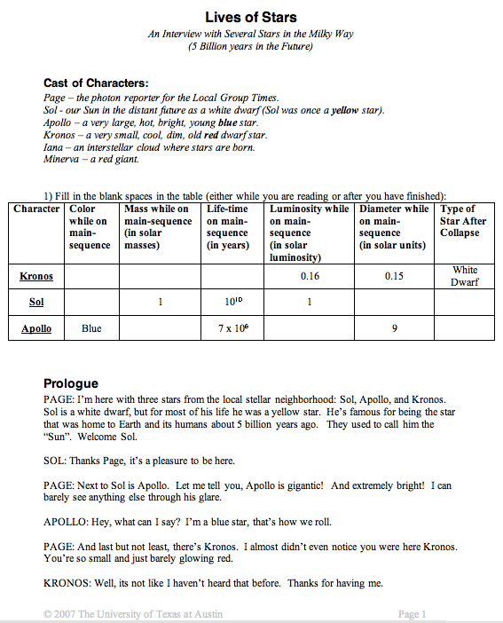

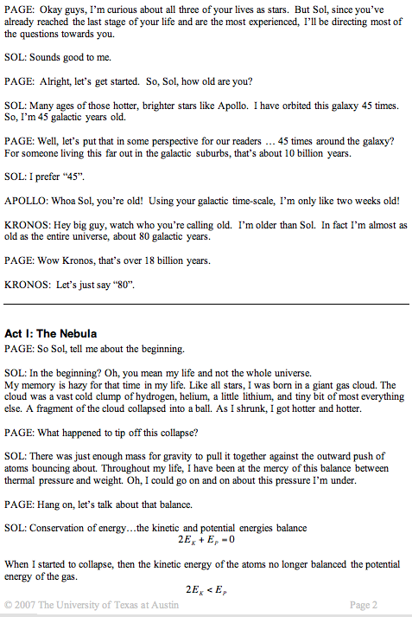

A galactic is year is about 225 million years.

The universe is currently estimated to be 13.7 billion years old (the play is set 5 billion years in the future).
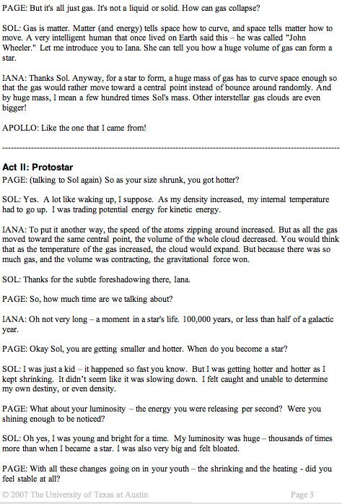
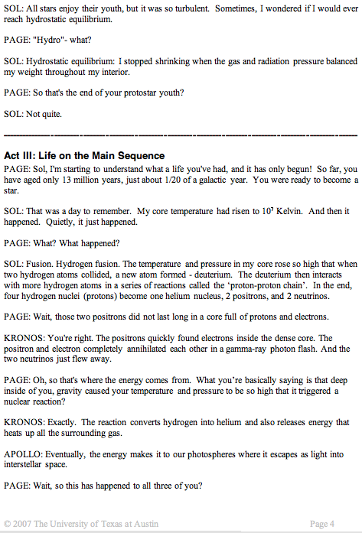
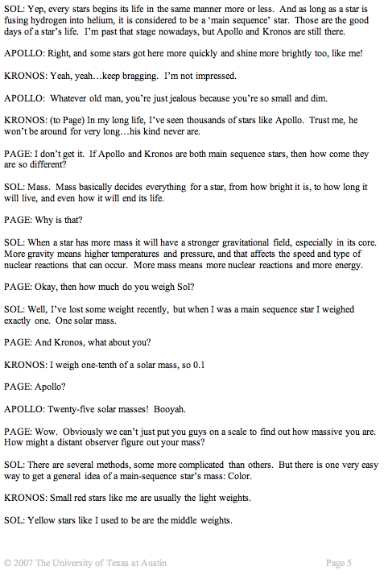
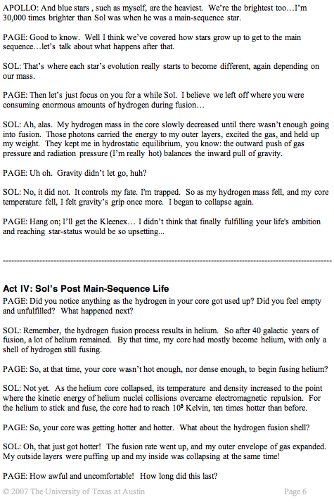

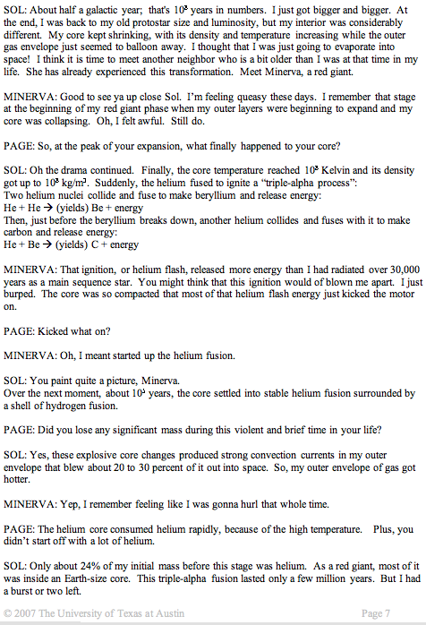

He is Helium,
Be is Beryllium,
C is Carbon
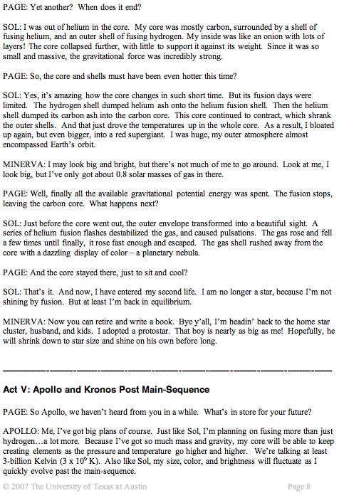
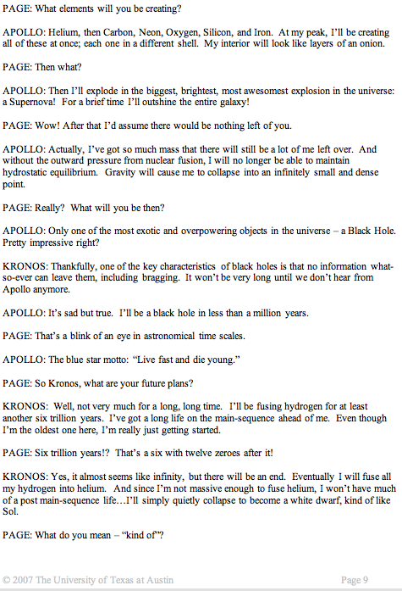
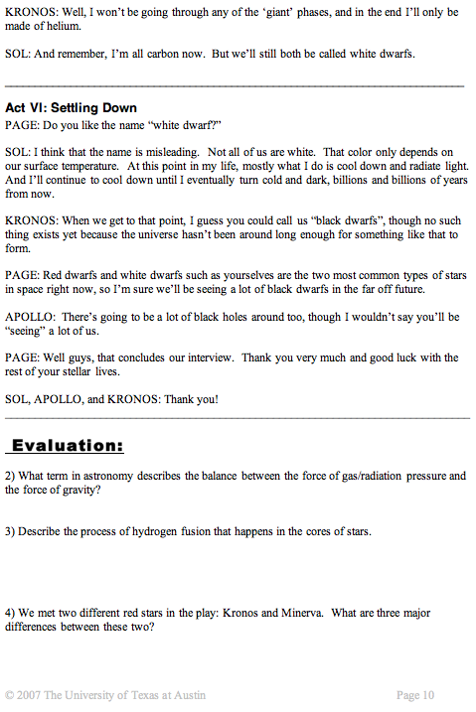
ANSWERS (in bold italics)

Evaluation:

…Question # 1 is on the very first page of the student guide…
1) Fill in the blank spaces in the table (either while you are reading or after you have finished):
Character | Color while on main-sequence | Mass while on main-sequence  (in solar masses) | Life-time on main-sequence  (in years) | Luminosity while on main-sequence  (in solar luminosity) | Diameter while on main-sequence  (in solar radii) | Type of Star After Collapse
Kronos | Red | 1/10 (0.1) | 6 x 10¹² | 0.16 | 0.15 | White Dwarf
Sol | Yellow | 1 | 10¹⁰ | 1 | 1 | White Dwarf
Apollo | Blue | 25 | 7 x 10⁶ | 30,000 | 9 | Black Hole

2) What term in astronomy describes the balance between the force of gas/radiation pressure and the force of gravity?

Hydrostaic Equilibrium

3) Describe the process of hydrogen fusion that happens in the cores of stars.

When the core temperature reaches 10⁷ Kelvin, two hydrogen atoms collide to form a new atom – deuterium. The deuterium then interacts with more hydrogen atoms in a series of reactions called the ‘proton-proton chain’. In the end, four hydrogen nuclei (protons) become on helium nucleus, 2 positrons, and 2 neutrinos. The positrons interact with electrons and both are quickly annihilated in a gamma-ray photon flash. The two neutrinos simply fly away.

4) We met two different red stars in the play: Kronos and Minerva. What are three major differences between these two?

Kronos is a red dwarf, Minerva is a red giant
Mass – Kronos is 0.1 solar masses, Minerva is 0.8 solar masses
Size – Kronos is small, Minerva is huge
Brightness – Kronos is very dim, Minerva is extremely bright
Temperature – Kronos is much cooler than Minerva
Longevity – Kronos is very old and will live for trillions of years, Minerva will soon turn into a white dwarf

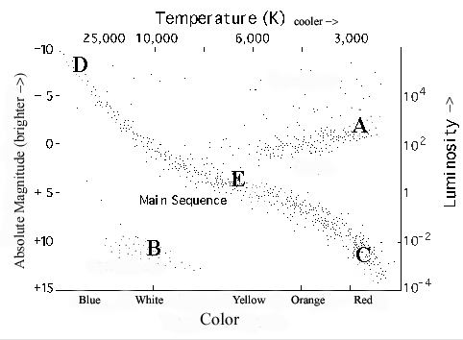
5) Below is a Hertzsprung-Russell diagram which plots a star’s color(temperature) vs. its luminosity(brightness). Each dot on the diagram represents an individual star. Main-sequence stars fall on the line that runs from the top-left to the bottom-right of the diagram:
On the diagram, write in the letter of each star in the part of the diagram where you think it belongs:

A) Minerva the solar-mass star that is now fusing helium in her core

B) Sol at the end of his life, after he collapsed

C) Kronos the small old star

D) Apollo the massive young star

E) Sol while he was fusing hydrogen in his core

***NOTE: This is the version of Question #5 that is in the Student Guide. There is an easier version of this question on the last page of this Teacher Guide. You may choose to print or project the easier version for lower grade-level classes…

The answers for the easier version are: II, IV, V, I, and III

6) If you look at a distant galaxy and notice that it contains a lot of bright blue stars in its spiral arms and dim red stars in between the arms, where would you say that the most star formation is happening? Why?

Most star formation is happening in the spiral arms. Bright blue stars are very young and do not live for very long, so the presence of blue stars always indicates a very active star-forming region of a galaxy.

7) If you look at a distant galaxy and notice that it contains many dim red stars but almost no blue stars, would you assume that this galaxy has a lot of extra gas, or very little extra gas? Why?

This galaxy has very little extra gas. Extra gas will produce new stars (blue stars). If there is no sign of new stars, then that likely means that there is not enough gas around to produce any more new (blue) stars.

8) Scientists are very interested in finding planets around stars that may be able to support intelligent life. Should they be looking around high-mass stars or low-mass stars? Why? (hint: most scientists believe that it takes billions of years for intelligent life to evolve.)

Low-mass stars would be the best candidates for having planets that support intelligent life, primarily because they have very long and stable lives – providing the conditions that are likely necessary to allow life to evolve. A blue star would not live long enough for one of its planets to be able to evolve intelligent life. The environment around a blue star would also likely be too intense, unstable, and violent for life.

Alternate Question #5

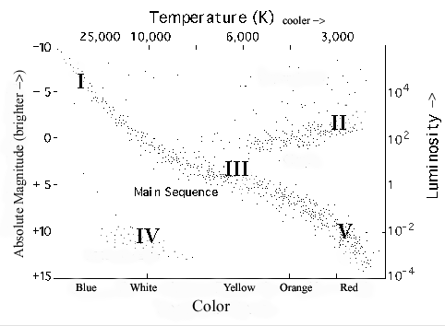
5) Below is a Hertzsprung-Russell diagram which plots a star’s color(temperature) vs. its luminosity(brightness). Each dot on the diagram represents an individual star. Main-sequence stars fall on the line that runs from the top-left to the bottom-right of the diagram:
Match the character and their stage in their life cycle to their corresponding position on the Hertzsprung-Russell diagram:
Character/Star-type | Roman numeral corresponding to Position on the HR diagram (I, II, III, IV, or V)
Minerva the solar-mass star that is now fusing helium in her core | ________
Sol at the end of his life, after he collapsed | ________
Kronos the small old star | ________
Apollo the massive young star | ________
Sol while he was fusing hydrogen in his core | ________

