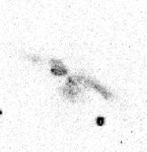
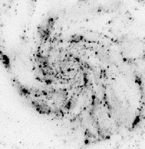
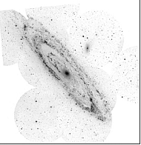
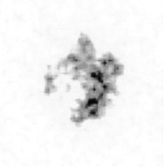
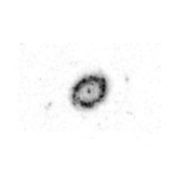
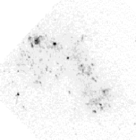
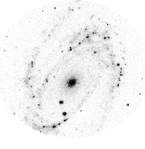
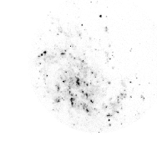
Ultraviolet – I
(ASTRO-1 UIT)
Ultraviolet – II
(GALEX)
Ultraviolet – III
(GALEX)
Ultraviolet – IV
(ASTRO-1)
Ultraviolet – VII
(ASTRO-2)
Ultraviolet – VIII
(ASTRO-1 UIT)
Ultraviolet – V
(ASTRO-1)
Ultraviolet – VI
(ASTRO-1)
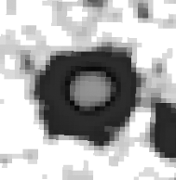
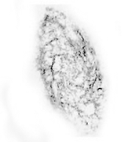
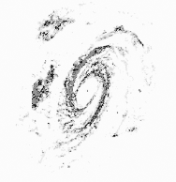
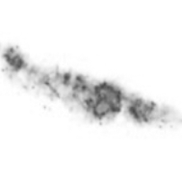
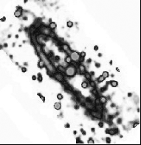
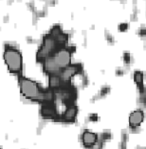
Radio – A
(NVSS)
Radio – B
(RAIUB/MPIFR Bonn)
Radio – C
(NVSS)
Radio – D
(NRAO)
Radio – E
(VLA)

Radio – F
(VLA + Merlin)
Radio – G
(Effelsberg)
Radio – H
(NVSS)
Visible – 1 M94
(KPNO)

Visible – 2 M100
(AAO)

Visible – 3 M31
(Jason Ware-Amateur)
Visible – 4 M101
(Grasslands Observatory)
Visible – 5 M33
(IAC/RGO/Malin)
Visible – 6 M82
(R. Gendler-Amateur)
Visible – 7 M81
(R. Gendler-Amateur)
Visible – 8 SMC
(AAO)

