Multiwavelength Astronomy: False Color Galaxies

Legend: 1 – Blue 2 – Green 3 – Pink/Orange 4 – Yellow
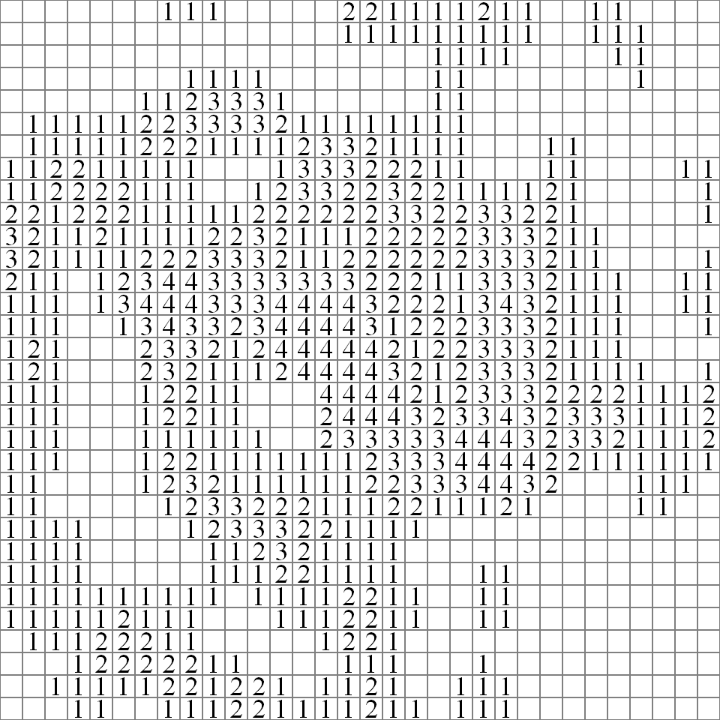

Each little square is basically a pixel. A pixel can only represent one color. If this same image were divided into thousands of even smaller pixels, it would look a lot cleaner and more like the real galaxy (it would also be a lot harder to color!). If this same image had only four huge pixels, you wouldn’t even be able to tell what it was. In general, the more pixels you have, the better…because you get more detail. You will see many real pictures of galaxies later in this activity. Some are very pixilated (too few pixels), hence low quality. And some are very detailed and beautiful. The differences in resolution are usually attributed to the variety of telescopes and technology used to gather the images.
Multiwavelength Astronomy: False Color Galaxies

Legend: 1 – Blue 2 – Green 3 – Pink/Orange 4 – Yellow
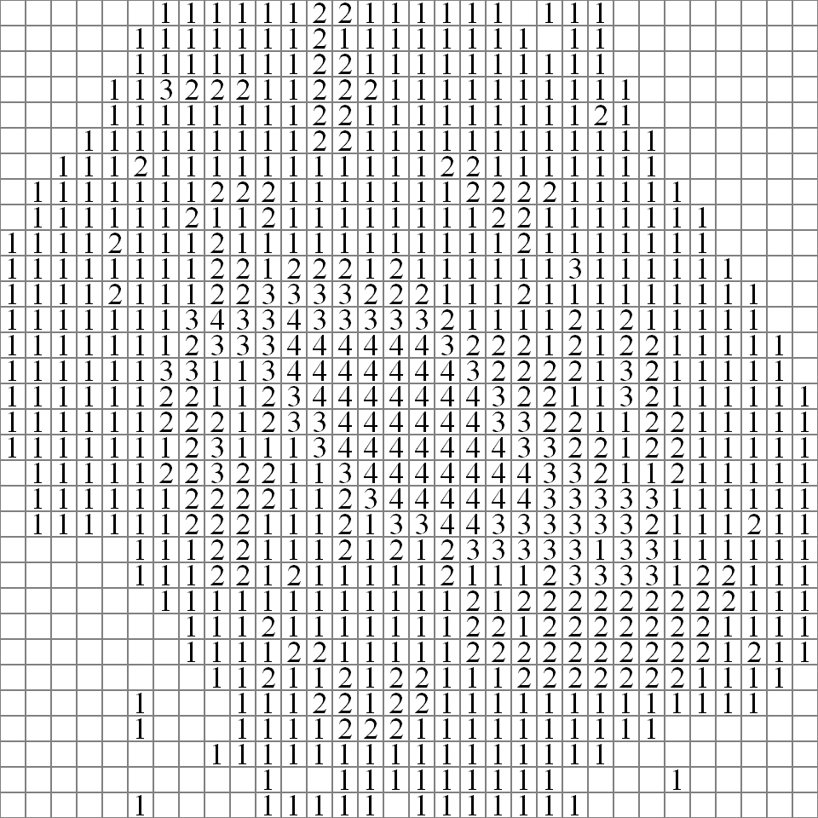

Each little square is basically a pixel. A pixel can only represent one color. If this same image were divided into thousands of even smaller pixels, it would look a lot cleaner and more like the real galaxy (it would also be a lot harder to color!). If this same image had only four huge pixels, you wouldn’t even be able to tell what it was. In general, the more pixels you have, the better…because you get more detail. You will see many pictures later in this activity. Some are very pixilated (too few pixels), hence low quality. And some are very detailed and beautiful. The differences in resolution are usually attributed to the telescopes and technology used to gather the images.

