The Galaxies and Cosmos Explorer Tool

Mary Kay Hemenway, Shardha Jogee, Sarah Miller, Aaron Smith, Achal Augustine, and Dan Lester (University of Texas at Austin)

The Galaxies and Cosmos Explorer Tool is an on-line web-based resource that will allow undergraduate students to access a legacy dataset of multi-wavelength data from the Hubble Space Telescope (HST) and other observatories on the evolution of galaxies and, through measurements of those at great distances, create a conceptual understanding of how our own galaxy in the present universe came to be. This software tool allows students to explore the HST Advanced Camera for Surveys images of over 8,000 galaxies over the last eight billion years, corresponding to 2/3 of the age of the Universe. The images are from Galaxy Evolution from Morphology and SEDs (GEMS) survey, one of the widest-area galaxy surveys conducted in two filters with HST to date; the redshifts are from Combo-17 (Classifying Objects by Medium-Band Observations in 17 Filters) survey. The range of size, brightness, color, and morphology can be considered a zoo for the population of galaxies in the early universe. The tool will allow students to interface through a map of the survey area with their browser to select individual galaxies. For each of over eight thousand galaxies, close-up images in two rest-frame wavelengths are provided; students can measure sizes, morphologies, and lookback time derived from concordance cosmology. Students can record their measurements, as well as reference information (such as the celestial coordinates and redshift) of each galaxy into spreadsheets for further analysis. They can use the celestial coordinates to extract further multiwavelength data from public archives and virtual observatories. A variety of exercises are planned for undergraduate instruction in both science major and introductory non-major classes

We thank the GEMS collaboration, and acknowledge support from NASA grants NAG5-13063 and NASA NNG 06GB99G, NSF grant AST-0607748, and the Faculty And Student Teams for Technology (FAST Tex) award from the University of Texas Division of Instructional Innovation and Assessment.

To explore the tool, go to http://www.as.utexas.edu/gcet

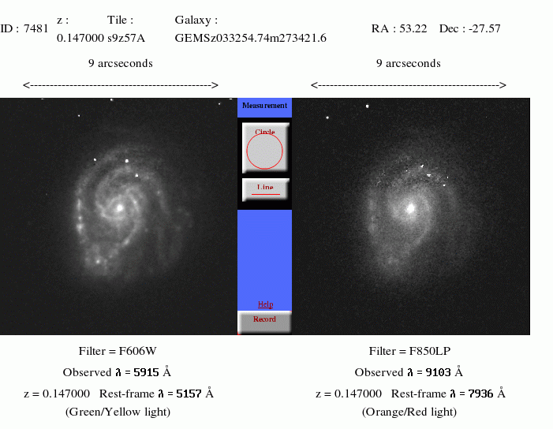

GEMS data from the ACS camera on HST is 30' by 30' in area. There are 77 tiles in the F606W filter and 78 in the F850LP filter. The central 15 tiles overlap with the GOODS survey. GCET allows students to individual examine tiles in both HST and ground view – and to measure individual galaxies in the two filters.

