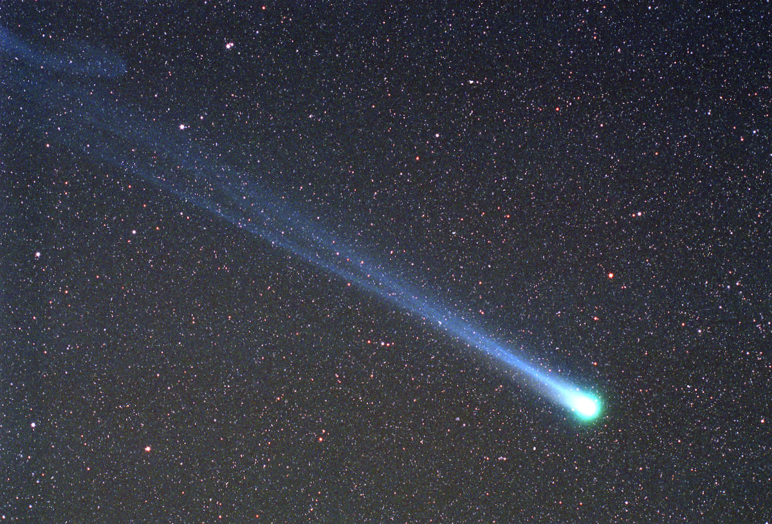
Comet Hyakutake Passes the Earth
Credit & Copyright: Doug Zubenel (TWAN)
Two Tails of Comet Lulin
Credit & Copyright: Richard Richins (NMSU)
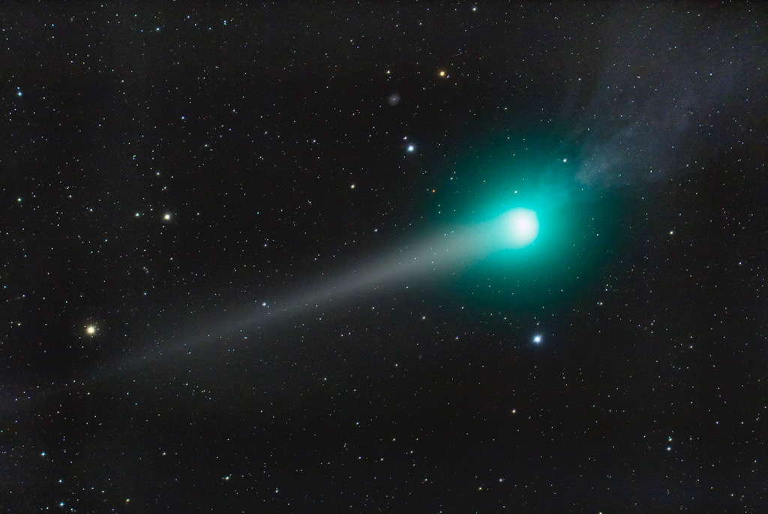
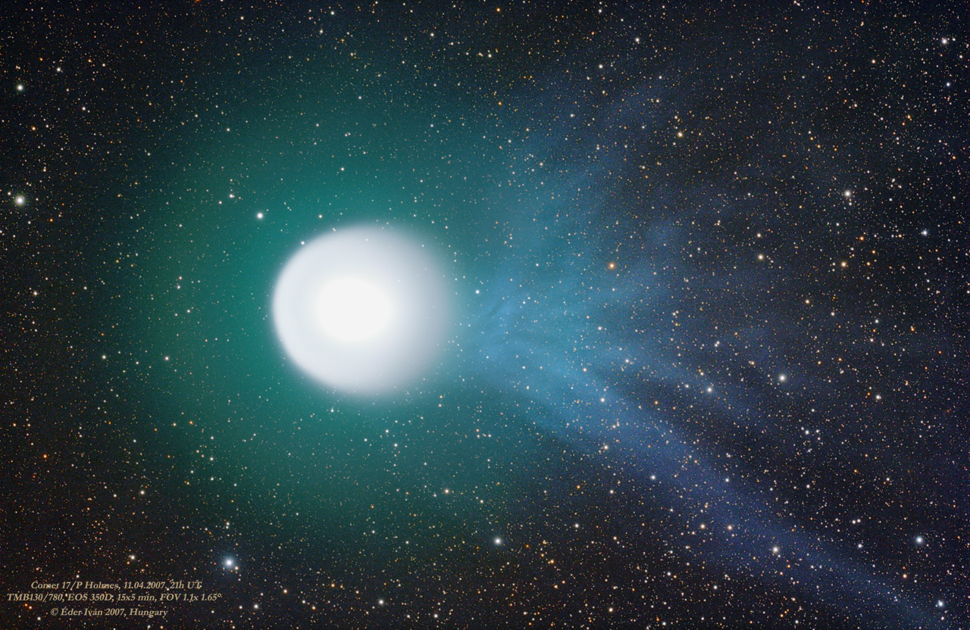
A Tale of Comet Holmes
Credit & Copyright: Ivan Eder and (inset) Paolo Berardi
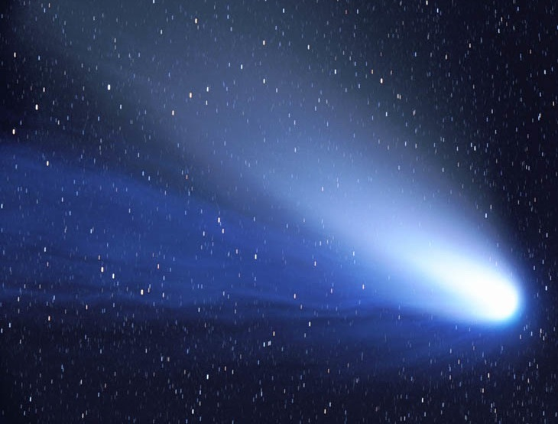
The Dust and Ion Tails of Comet Hale-Bopp
Credit & Copyright: John Gleason (Celestial Images)
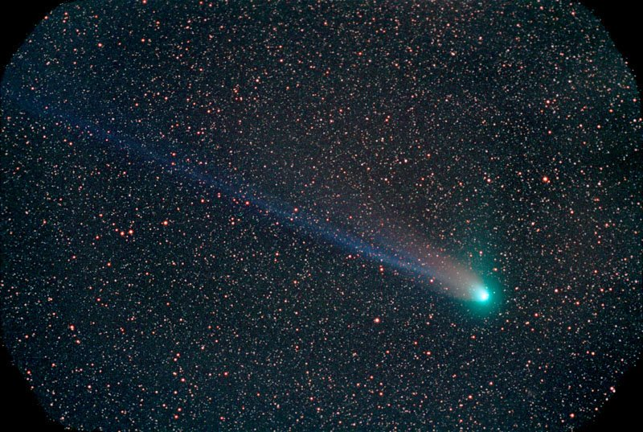
The Tails of Comet NEAT (Q4)
Credit & Copyright: Chris Schur
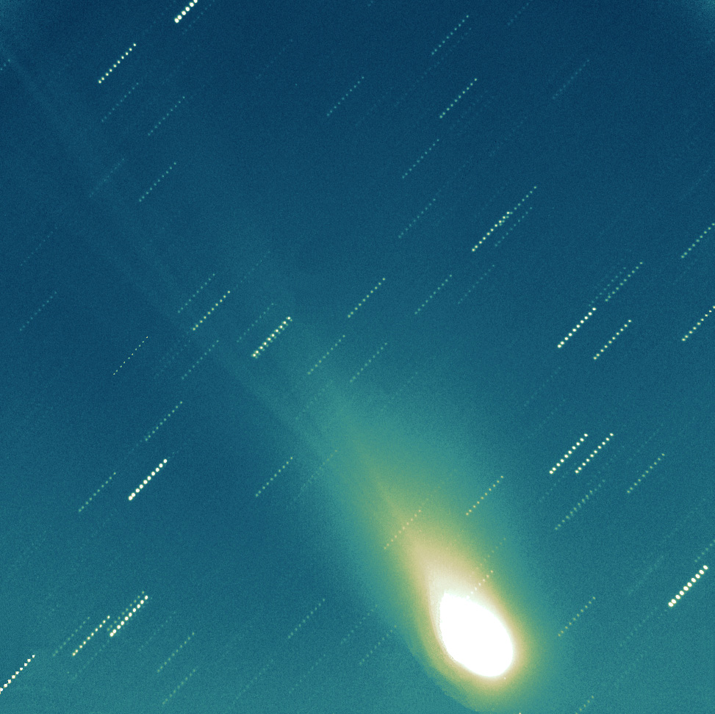
Tails Of Comet LINEAR
Credit & Copyright: Jure Skvarc, Bojan Dintinjana, Herman Mikuz (Crni Vrh Observatory, Slovenia)
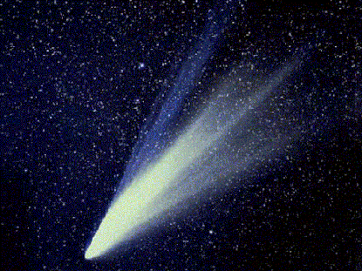
Two Tails of Comet West
Credit: Observatoire de Haute, Provence, France

TEACHER’S NOTES:

APOD: 2009 December 16 - Comet Hyakutake Passes the Earth
Explanation: In 1996, an unexpectedly bright comet passed by planet Earth. Discovered less than two months before, Comet C/1996 B2 Hyakutake came within only 1/10th of the Earth-Sun distance from the Earth in late March. At that time, Comet Hyakutake, dubbed the Great Comet of 1996, became the brightest comet to grace the skies of Earth in 20 years. During its previous visit, Comet Hyakutake may well have been seen by the stone age Magdalenian culture, who 17,000 years ago were possibly among the first humans to live in tents as well as caves. Pictured above near closest approach as it appeared on 1996 March 26, the long ion and dust tails of Comet Hyakutake are visible flowing off to the left in front of a distant star field that includes both the Big and Little Dippers. On the far left, the blue ion tail appears to have recently undergone a magnetic disconnection event. On the far right, the comet's green-tinted coma obscures a dense nucleus of melting dirty ice estimated to be about 5 kilometers across. A few months later, Comet Hyakutake began its long trek back to the outer Solar System. Because of being gravitationally deflected by massive planets, Comet Hyakutake is not expected back for about 100,000 years.

APOD: 2009 February 25 - Two Tails of Comet Lulin
Explanation: Go outside tonight and see Comet Lulin. From a dark location, you should need only a good star map and admirable perseverance -- although wide-field binoculars might help. Yesterday, Comet Lulin passed its closest to Earth, so that the comet will remain near its brightest over the next few days. The comet is currently almost 180 degrees around from the Sun and so visible nearly all night long, but will appear to move on the sky about 10 full moons a night. In this image, Comet Lulin was captured in spectacular form two nights ago from New Mexico, USA. The central coma of the comet is appearing quite green, a color likely indicating glowing molecular carbon gasses. Bright stars and a distant spiral galaxy are clearly visible in the image background. The yellow dust tail, reflecting sunlight, is visible sprawling to the coma's left trailing behind the comet, while the textured bluish-glowing ion tail is visible to the coma's right, pointing away from the Sun. Over the past few weeks, from the current vantage point of Earth, these two tails appeared to point in opposite directions. Comet Lulin is expected to slowly fade over the next few weeks.

APOD: 2007 November 10 - A Tale of Comet Holmes
Explanation: A beautiful blue ion tail has become visible in deep telescopic images of Comet Holmes. Pointing generally away from the Sun and also planet Earth, the comet's ion tail is seriously foreshortened by our extreme viewing angle. Still, enthusiastic comet watchers have remarked that on the whole, the compact but tentacled appearance suggests a jellyfish or even a cosmic calamari. This stunning view of the comet's greenish coma and blue tail was recorded on November 4 in clear skies near Budapest, Hungary. The colors are caused by molecules in the tenuous gas, like C2 (green) and CO+ (blue), fluorescing in sunlight. In a more recent development, the dramatic inset is a deep image from L'Aquila in central Italy on November 8, showing the ion tail disconnecting from the comet.

APOD: 2005 May 22 - The Dust and Ion Tails of Comet Hale-Bopp
Explanation: In 1997, Comet Hale-Bopp's intrinsic brightness exceeded any comet since 1811. Since it peaked on the other side of the Earth's orbit, however, the comet appeared only brighter than any comet in two decades. Visible above are the two tails shed by Comet Hale-Bopp. The blue ion tail is composed of ionized gas molecules, of which carbon monoxide particularly glows blue when reacquiring electrons. This tail is created by the particles from the fast solar wind interacting with gas from the comet's head. The blue ion tail points directly away from the Sun. The light colored dust tail is created by bits of grit that have come off the comet's nucleus and are being pushed away by the pressure of light from the Sun. This tail points nearly away from the Sun. The above photograph was taken in March 1997.

APOD: 2004 May 12 - The Tails of Comet NEAT Q4
Explanation: Comet NEAT (Q4) is showing its tails. As the large snowball officially dubbed Comet C/2001 Q4 (NEAT) falls toward the inner Solar System, it has already passed the Earth and will reach its closest approach to the Sun this coming Saturday. Reports place the comet at third magnitude, making it easily visible to the unaided eye to northern sky gazers observing from a dark location just after sunset. The above image was captured last Saturday from Happy Jack, Arizona, USA. Visible is a long blue ion tail, a blue coma surrounding the comet's nucleus, and a shorter but brighter sunlight reflecting dust tail. Q4 will likely drop from easy visibility during the next month as it recedes from both the Earth and the Sun. Another separate naked-eye comet, Comet Linear (T7), is also as bright as third magnitude and should remain bright into June.

APOD: 2000 July 27 - Tails Of Comet LINEAR
Explanation: Comet C/1999 S4 LINEAR is only one of many comets discovered with the Lincoln Near Earth Asteroid Research (LINEAR) telescope operating near Soccoro, New Mexico, USA. Traveling steadily southward through Earth's night sky, C/1999 S4 passed perihelion (closest approach to the Sun) yesterday on what is likely its first trip through the inner solar system. Now fading, comet LINEAR became no brighter than about 6th magnitude, but is still easily visible with binoculars in northern hemisphere skies. While the memorable comets Hale-Bopp and Hyakutake were much brighter, comet LINEAR is displaying delightful tails evident in this false-color composite image from the Crni Vrh Observatory in Slovenia. The combined series of exposures made on July 22nd are registered on the comet. In the resulting picture, stars appear as rows of dots, but the faint structures in the comet's tail are beautifully recorded. Presently seen moving from Ursa Major to Leo this comet LINEAR will begin to shine in southern hemisphere skies in August.

APOD: August 26, 1995 - Two Tails of Comet West
Explanation: Here Comet West is seen showing two enormous tails that wrap around the sky. The ion tale of a comet usually appears more blue and always points away from the Sun. The dust tail trailing the comet's nucleus is the most prominent. Comet West was a visually spectacular comet, reaching its most picturesque in March of 1976. A comet this bright occurs only about once a decade. Comets are really just large dirty snowballs that shed material when they reach the inner solar-system. Many astronomers are hopeful that Comet Hale-Bopp will look as spectacular as this in the spring of 1997.

